

**CAPSTONE PROJECT REPORT**

**Report 3 – Software Requirement Specification**

**– Da Nang, September 2023 –**

**TABLE OF CONTENTS**

I. Record of Changes 1

II. Software Requirement Specification 2

1. Product Overview 2

2. User Requirements 2

2.1 Actors 2

2.2 Use cases 2

2.3 Feature Common 9

3. Functional Requirements 51

3.1 System Functional Overview 51

3.2 Authentication 58

3.3 Landing Page 62

3.4 User Profile 63

3.5 Topic 66

3.6 Conversation 67

3.7 Community 69

3.9 Contact Us 71

4. Non-Functional Requirements 74

4.1. External Interfaces 74

4.2. Quality Attributes 74

5. Requirement Appendix 75

5.1 Business Rules 75

5.2 Common Requirements 76

5.2 Application Messages List 77

**TABLE OF TABLES**

Table 1. All actors in the system 2

Table 2. Use case Description 9

Table 3. Screen Descriptions 53

Table 4. Screen Authorization 55

Table 6. Entities Description 58

Table 7. Business Rule 76

Table 8. Common Requirements 77

Table 9. Application Message List 78

**TABLE OF FIGURES**

Figure 1. Overview of TopicTalks Platform 2

Figure 2. TopicTalks Platform Use Case Diagram 4

Figure 3. Use Case for Authentication 5

Figure 4. Use Case for User 6

Figure 5. Use Case for Host Group 7

Figure 6. Use Case for Admin 8

Figure 7. Swimlane diagram for Joining and Creating Group 9

Figure 8. Screen Flows for each actor in TopicTalks Platform 53

Figure 8. Entity Relationship Diagram 58

Figure 9. Sign-In Screen 61

Figure 10. Sign Up Screen 62

Figure 11. Forgot Password Screen 63

Figure 12. Reset Password Screen 63

Figure 13. Landing Page Screen 64

Figure 14. Home Page Screen 65

Figure 15. Personal Profile Screen 65

Figure 16. List Friend Screen 66

Figure 17. Setting Profile Screen 67

Figure 16. Topic Overview Screen 67

Figure 17. Topic Detail Screen 68

Figure 18. Recent Message Box Screen 69

Figure 19. All Posts Screen 70

Figure 20. Post Detail Screen 70

Figure 21. All Group Chat Screen 71

Figure 22. Create New Group Chat 72

Figure 23. Conversation Screen 72

Figure 24. Notification Screen 73

Figure 25. Contact Us Screen 73

Figure 26. Dashboard Screen 74

Figure 27. Admin’s User Screen 74

Figure 28. Admin’s Topic Screen 75

Figure 29. Admin’s Post Screen 76

Figure 30. Admin’s FAQ Screen 76

# **I. Record of Changes**

| **Date** | **A*, M, D** | **In charge** | **Change Description** |
| --- | --- | --- | --- |
| 01/09/2023 | A | Anonymity Team | Add initial version |
| 23/09/2023 | M | Anonymity Team | Update mentor’s comment part 1 |
| 13/12/2023 | M | Anonymity Team | Update mentor’s comment part 2 |
|  |  |  |  |
|  |  |  |  |
|  |  |  |  |
|  |  |  |  |
|  |  |  |  |
|  |  |  |  |
|  |  |  |  |
|  |  |  |  |
|  |  |  |  |
|  |  |  |  |
|  |  |  |  |
|  |  |  |  |

*A - Added M - Modified D- Deleted

# 

# **II. Software Requirement Specification**

## **Product Overview**

Our anonymous topic-based chat platform - TopicTalks, was developed to cater to the needs of individuals seeking a safe and anonymous way to engage in topic-based discussions. By connecting people worldwide, our platform enables them to communicate and exchange information on the issues they care about.

One of the unique aspects of our platform is that it allows users to participate in conversations based on their interests, including current hot topics. This facilitates the discovery of like-minded individuals and boosts users confidence in communication.

One of the main advantages of our platform is that it provides anonymous access when participating in the system. This ensures that the user's personal information remains confidential and the fun of not knowing who the next person they chat with will be. Our platform also provides a means for users to interact anonymously through posts. They can share their moods, ask questions, receive answers, and gain insights into their chosen topics. This combination of features makes our chat platform especially appealing to individuals who may struggle to comfortably share their problems due to fear of criticism from people they know.

In general, our Anonymous Topic-based Chat Platform offers an intriguing website for individuals seeking to make new friends and deepen their understanding of their chosen topics. It caters not only to users in Vietnam but also to individuals worldwide, serving as a gathering place for people to come together and share fascinating experiences.

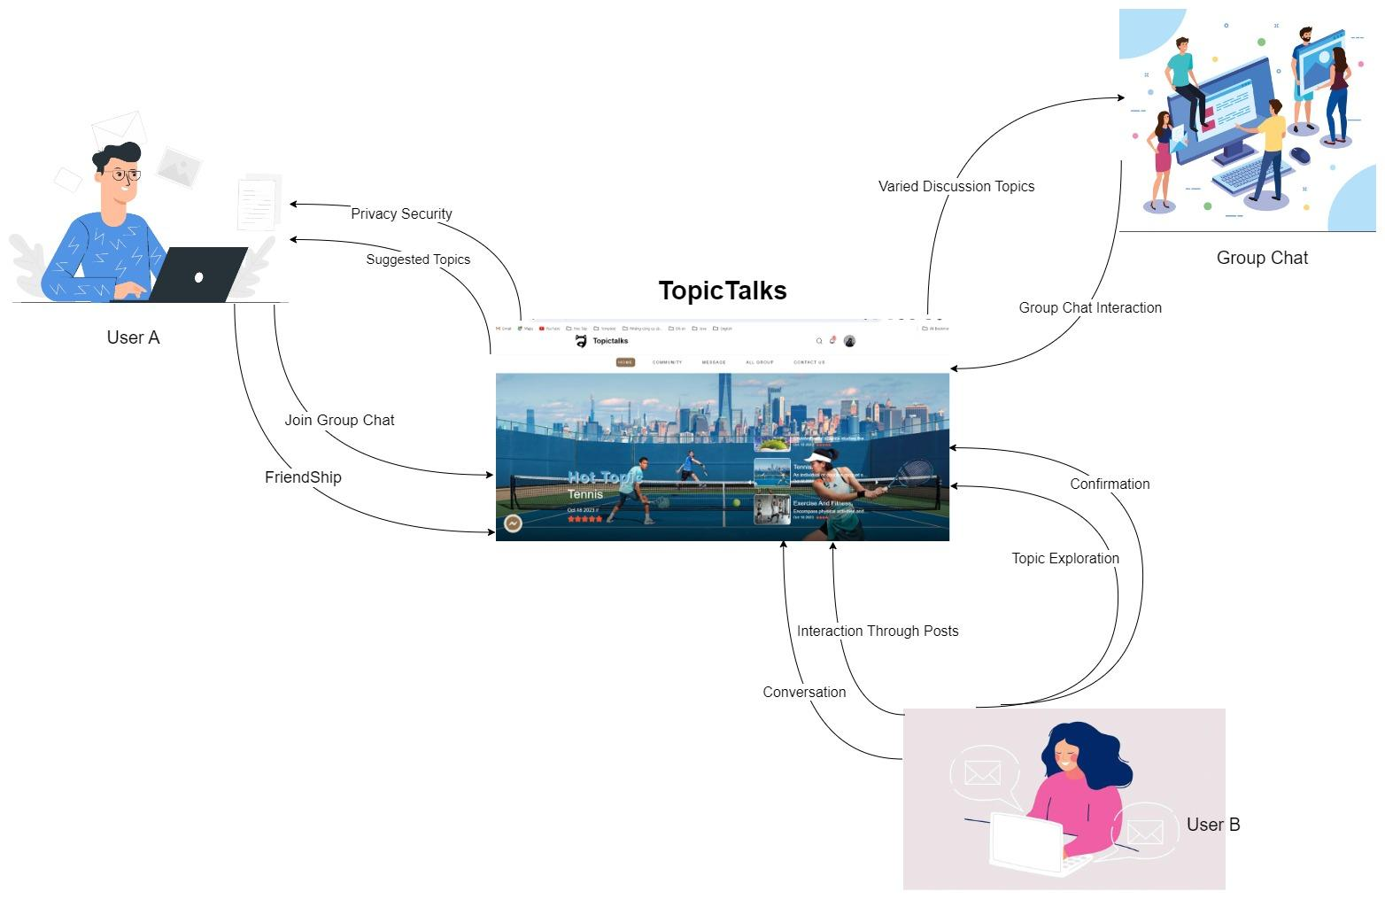

##### Figure 1. Overview of TopicTalks Platform

## **User Requirements**

### **2.1 Actors**

| **Actor** | **Actor** | **Description** |
| --- | --- | --- |
| 1 | Guest | A guest is someone who accesses the TopicTalks system without logging in. They have access to the landing page and can see an introductory overview of the system's features. |
| 2 | User | User are individuals who have accounts in the TopicTalks system. They have the ability to manage their own profiles, join random chats, and chat groups, and post and leave comments on other members' posts. |
| 3 | Host Group | User who creates the chat group has the ability to manage group members, oversee chat content among members, approve or reject new members, and edit group information |
| 4 | Admin | Administrators who have full rights to manage the system such as user accounts, conversations, and existing topics in the TopicTalks system... will be called Administrators. |

#### Table 1. All actors in the system

### **2.2 Use cases**

#### 2.2.1 Diagram(s)

#### 2.2.1.1 Use Case Overview

## Below is an overview of the use cases for the TopicTalks Platform.

### 

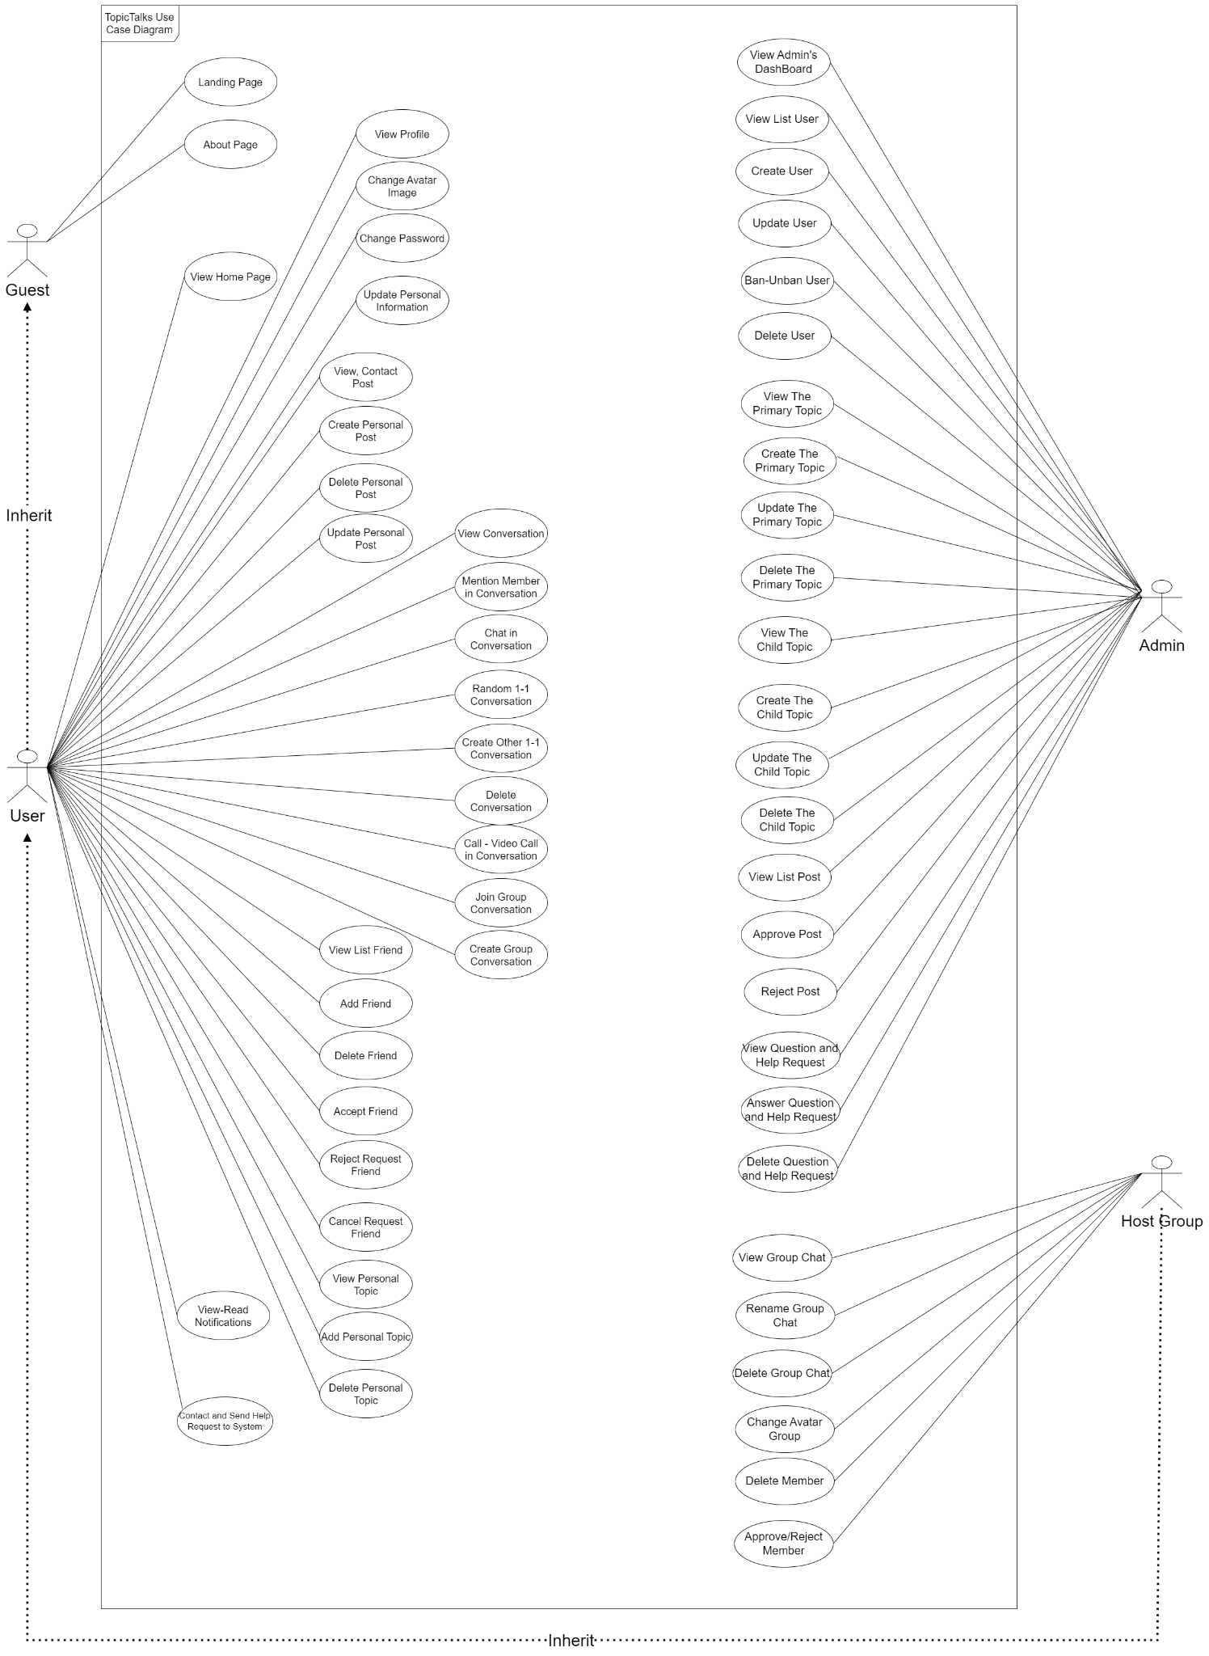

##### Figure 2. TopicTalks Platform Use Case Diagram

#### 2.2.1.2 Use Case for Authentication

In the TopicTalks system, all users are required to undergo an authentication process when they enter the platform. This process verifies the user's identity and ensures that only authorized individuals are granted access. By implementing authentication, the system can safeguard sensitive information and prevent unauthorized entry.

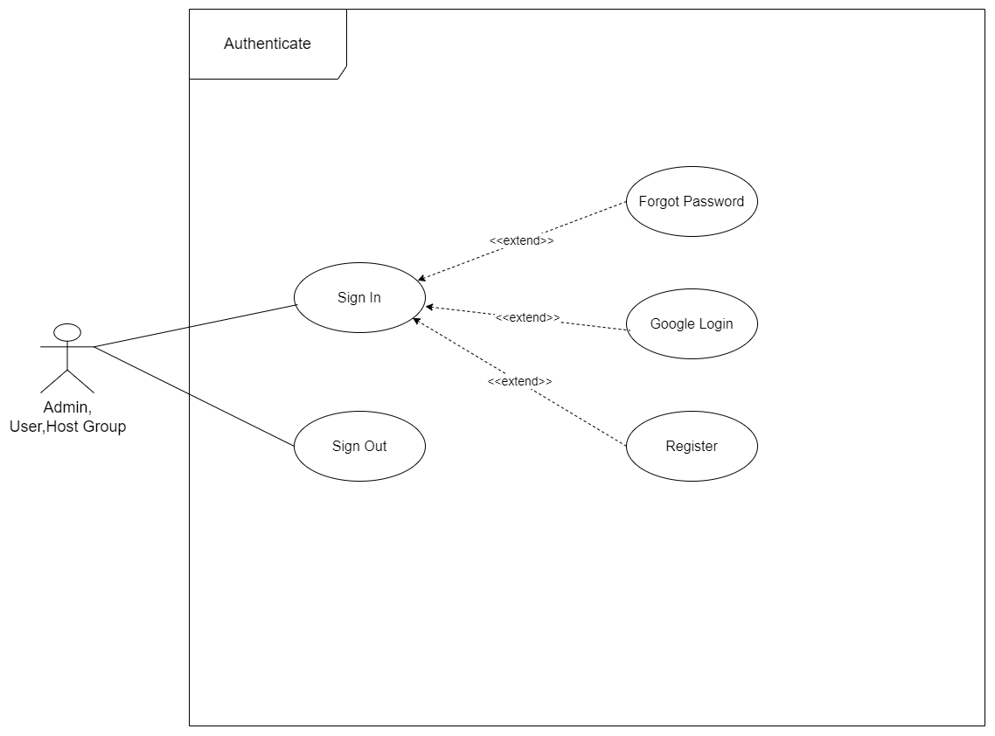

##### Figure 3. Use Case for Authentication

#### 2.2.1.3 Use Case for User

##### Below is a subsystem use case for the User actor.

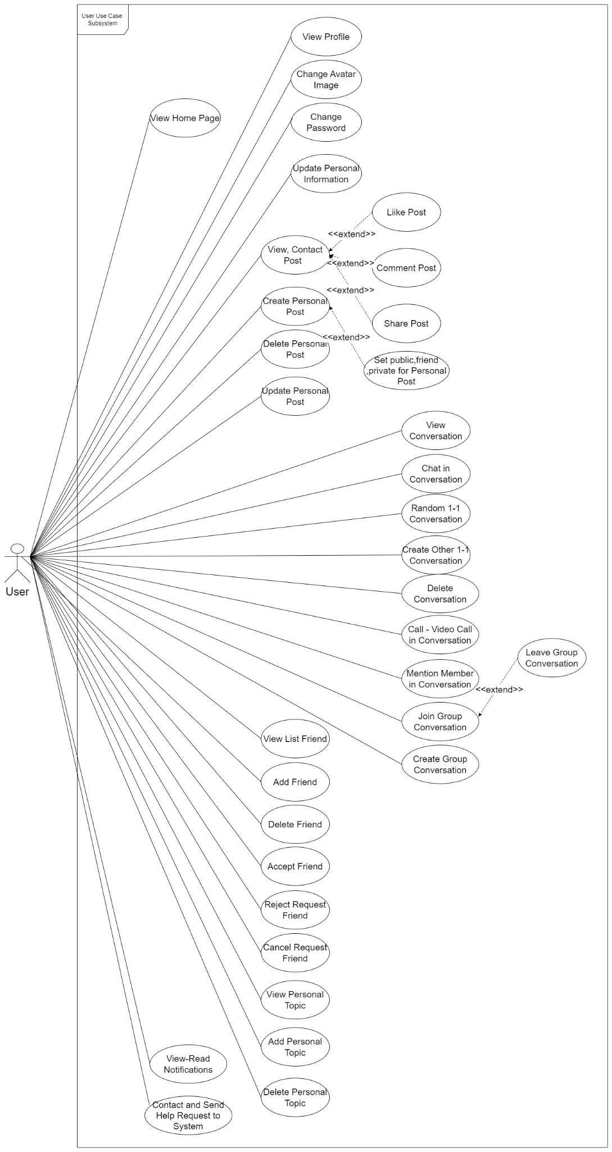

##### Figure 4. Use Case for User

#### 2.2.1.4 Use Case for Host Group

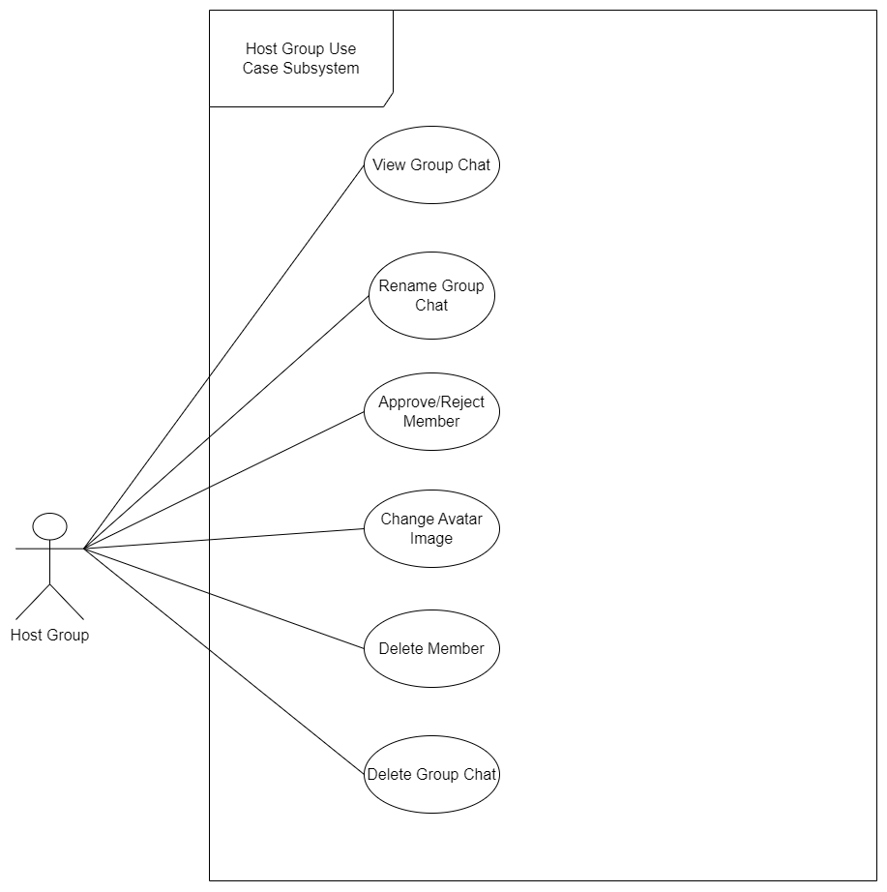

##### Figure 5. Use Case for Host Group

#### 2.2.1.5 Use Case for Admin

Below is a subsystem use case for the Admin actor.

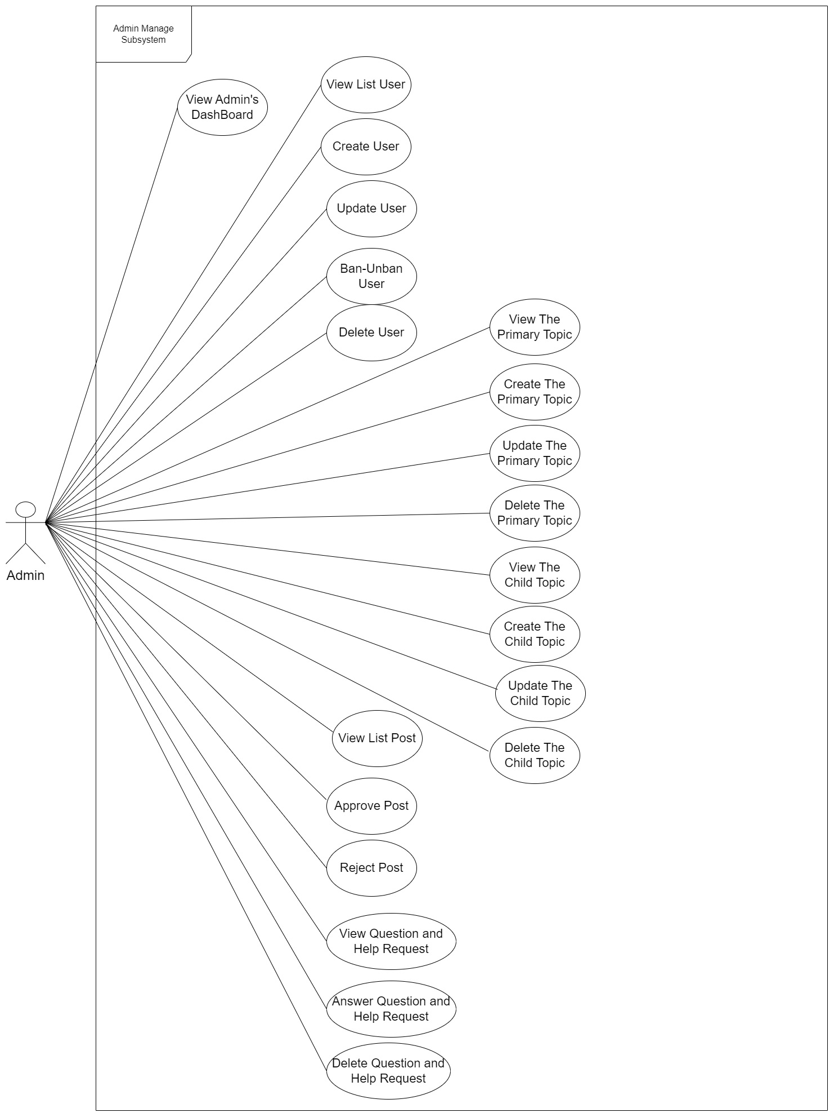

##### Figure 6. Use Case for Admin

#### 2.2.2 Swimlane Diagram

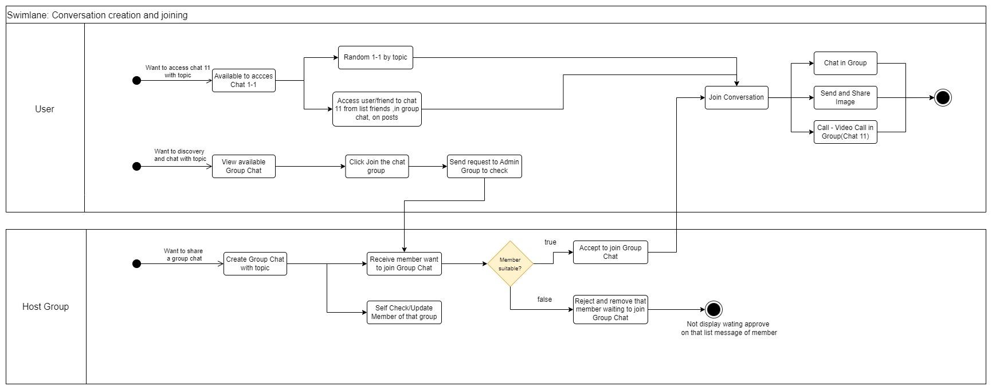

##### Figure 7. Swimlane diagram for Joining and Creating Group

#### 2.2.3 Descriptions

Below is a summary of the use cases present in the TopcicTalks system:

| **ID** | **Use Case** | **Actors** |
| --- | --- | --- |
| UC-1 | Sign Up | Guest |
| UC-2 | Sign In | User, Admin |
| UC-3 | Sign Out | User, Admin |
| UC-4 | Forgot Password | User, Admin |
| UC-5 | View Landing Page | Guest, User, Admin |
| UC-6 | View Home Page | User |
| UC-7 | Search Topics | User |
| UC-8 | View My Profile | User |
| UC-9 | Update Personal Information | User |
| UC-10 | View Other User’s Wall | User |
| UC-11 | Change Profile Photo | User |
| UC-12 | View All Topics | User |
| UC-13 | View Hot Topics | User |
| UC-14 | View Recommended Topics | User |
| UC-15 | Rating Topics | User |
| UC-16 | View Popular Posts | User |
| UC-17 | View All Posts | User |
| UC-18 | View Posts By Topic | User |
| UC-19 | View Post Detail | User |
| UC-20 | Create Post | User |
| UC-21 | Edit, Delete Post | User |
| UC-22 | Set Public, Friends, Private For Post | User |
| UC-23 | Approve, Reject Post | Admin |
| UC-24 | Comment Item | User |
| UC-25 | View Comment | User |
| UC-26 | Update, Delete Comment | User |
| UC-27 | Like Post | User |
| UC-28 | View Total Like Of Post | User |
| UC-29 | Share Post | User |
| UC-30 | View List Friend | User |
| UC-31 | Add Friend | User |
| UC-32 | Delete Friend | User |
| UC-33 | View All Group Conversation | User |
| UC-34 | Join Group Conversation | User |
| UC-35 | Leave Group Conversation | User |
| UC-36 | Create New Group Conversation | User |
| UC-37 | Delete Member in Group Conversation | Host Group |
| UC-38 | Approve User From Joining Chat Conversation | Host Group |
| UC-39 | Reject User From Joining Chat Conversation | Host Group |
| UC-40 | Delete Group Conversation | Host Group |
| UC-41 | Chat In Groups | User,Host Group |
| UC-42 | Random Chats With User On The Same Topic | User |
| UC-43 | Delete Conversation | User |
| UC-44 | Chat With Strangers | User |
| UC-45 | Chat With Friends | User |
| UC-46 | Call - Call Video in Conversation | User |
| UC-47 | Search For Conversation | User |
| UC-48 | View Recent Message Box | User |
| UC-49 | Create Question & Send to System | User |
| UC-50 | Answer User Questions About The System | Admin |
| UC-51 | View, Read Notification | User |
| UC-52 | View Dashboard | Admin |
| UC-53 | Create Parent Topic | Admin |
| UC-54 | Update Parent Topic | Admin |
| UC-55 | Create Children Topic | Admin |
| UC-56 | Update Children Topic | Admin |
| UC-57 | Disable Children Topic | Admin |
| UC-58 | View User's Personal Information | Admin |
| UC-59 | Ban Users | Admin |
| UC-60 | Unban Users | Admin |

#### Table 2. Use case Description

### **2.3 Feature Common**

#### 2.3.1 Authenticate User

#### 2.3.1.1 Sign Up

| Use Case ID: | UC-01 | Use Case Name: | Sign Up |
| --- | --- | --- | --- |
| Created By: | AnhHT, TanTQ, SonLV | Date Created: | 02/09/2023 |
| Primary Actor: | Guest | Secondary Actor: | None |
| Description: | This use case describes the process of new visitors creating an account on the TopicTalks website, and providing their personal information such as their name, email address, and password to become registered users. | | |
| Priority: | High | | |
| Trigger: | User create accounts to log into the system. | | |
| Preconditions: | PRE-01: The guest has a valid email address. | | |
| Post-Conditions: | POST-1: TopicTalks system works stably, without error.  POST-2: The system creates a new user account and assigns the guest a unique identifier upon successful verification. | | |
| Basic Flow: | 1. The guest accesses the landing page.  2. Click on the “Join Now” button.  3. System redirects to the SIGN IN page.  4. Click on the “Sign up account?” link.  5. System redirects to the SIGN UP page.  6. Type in all the required fields needed to create an account.  7. Click on the button “SIGN UP”. 8. Verify email with the code sent to the user's email address.  9. System redirects to the SIGN IN page. | | |
| Alternative Flow: | None | | |
| Exception Flow: | **5a. The guest fills in an invalid username or email.**  5a1. The system gives an error message and informs the guest to fill in another username, or email.  **5b. The guest fills in a username or email that already exists.**  5b1. The system gives an error message and informs the guest to fill in another username, or email. | | |
| Business Rules: | BR-03, BR-04, BR-02 | | |

#### 

#### 2.3.1.2 Sign In

| Use Case ID: | UC-02 | Use Case Name: | Sign In |
| --- | --- | --- | --- |
| Created By: | AnhHT, TanTQ | Date Created: | 04/09/2023 |
| Primary Actor: | User, Admin | Secondary Actor: | None |
| Description: | This use case describes how a user can sign in to their account. The system verifies the credentials and grants access to the user's account. | | |
| Priority: | High | | |
| Trigger: | User want to log in to the TopicTalks system using a TopicTalks account or Google login methods. | | |
| Preconditions: | PRE-01: The user has a created and valid account.  PRE-02: The user account has been authorized. | | |
| Post-Conditions: | POST-1: TopicTalks system works stably, without error.  POST-2: The user successfully logged into the TopicTalks system. | | |
| Basic Flow: | 1. User access to the SIGN IN page.  2. User to log in with the TopicTalks account.  3. The user types in account info and clicks on the SIGN IN button.  4. The system verifies the user's account information and allows the user to access the system.  5. The System redirects to the Home page. | | |
| Alternative Flow: | 2a. User to log in with Gmail method.  Click on the button “Sign in with Google”.  3a. User type in their Google account and click log in.  4a. Google verifies the account’s information and allows the user access to the system. | | |
| Exception Flow: | **4b. The system fails to verify the user's account information and displays the message.**  4b1. User stop the login process.  *Use case stops.*  4b2. User clicks on the Forgot password. | | |
| Business Rules: | BR-03, BR-16 | | |

#### 

#### 2.3.1.3 Sign Out

| Use Case ID: | UC-03 | Use Case Name: | Sign Out |
| --- | --- | --- | --- |
| Created By: | TanTQ, AnhHT | Date Created: | 05/09/2023 |
| Primary Actor: | User, Admin | Secondary Actor: | None |
| Description: | This use case describes how a user can sign out of their account, which clears any active cookies and logs them out of the system. | | |
| Priority: | High | | |
| Trigger: | The user wants to log out of the TopicTalks website and click the log-out option. | | |
| Preconditions: | PRE-01: User has logged in into TopicTalks system. | | |
| Post-Conditions: | POST-1: TopicTalks system works stably, without error.  POST-2: The system navigates the users back to the landing page. | | |
| Basic Flow: | 1. User hovers over the avatar in the header.  2. Click on the log out option.  3. The user is now no longer determined as any role but Guest.  4. The guest will be navigated back to the SIGN IN page. | | |
| Alternative Flow: | None | | |
| Exception Flow: | None | | |
| Business Rules: | BR-16 | | |

#### 

#### 2.3.1.4 Forgot Password

| Use Case ID: | UC-04 | Use Case Name: | Forgot Password |
| --- | --- | --- | --- |
| Created By: | SonLV, AnhHT | Date Created: | 10/10/2023 |
| Primary Actor: | User, Admin | Secondary Actor: | None |
| Description: | This use case describes how a user can reset their forgotten password by verifying their email address and clicking on the password reset link sent by the system. | | |
| Priority: | Medium | | |
| Trigger: | The user clicks on the forgot password link to be able to reset their password. | | |
| Preconditions: | PRE-01: The user already has a valid account and valid email address. | | |
| Post-Conditions: | POST-1: TopicTalks system works stably, without error.  POST-2: The user changed their account password successfully. | | |
| Basic Flow: | 1. User access to the sign-in page.  2. The user clicks on “Forgot password?” on the login screen.  3. The user will fill in their email address in the email field.  4. The TopicTalks system will send a link to reset the password to the user’s email address.  5. The user clicks on the link in their mail and gets redirected to the reset password screen.  6. The user types in the new password and clicks confirm the new password. 7. System redirects back to the login screen. | | |
| Alternative Flow: | None | | |
| Exception Flow: | 3a. The user fills in an invalid email address  3a1. The system gives an error message and informs the guest to fill in a valid email | | |
| Business Rules: | MSG03, MSG04, BR-02, BR-01, BR-04 | | |

#### 

#### 2.3.2 View Common Feature

#### 2.3.2.1 View Landing Page

| Use Case ID: | UC-05 | Use Case Name: | View Home Page |
| --- | --- | --- | --- |
| Created By: | LinhDT | Date Created: | 10/09/2023 |
| Primary Actor: | Guest, User, Admin | Secondary Actor: | None |
| Description: | This use case describes how users can get an introduction to the website's features and benefits of participating in the TopicTalks platform. | | |
| Priority: | Medium | | |
| Trigger: | User log in to the TopicTalks system and the view Homepage. | | |
| Preconditions: | PRE-01: User logged in to the system. | | |
| Post-Conditions: | POST-1: TopicTalks system operates stably, without errors.  POST-2: User can navigate to other pages or features of the web. | | |
| Basic Flow: | 1. User logs in to TopicTalks website.  2. The system displays the landing page to the user.  3. User view available features and content on the landing page. | | |
| Alternative Flow: | None | | |
| Exception Flow: | None | | |
| Business Rules: | BR-16 | | |

#### 

#### 2.3.2.2 View Home Page

| Use Case ID: | UC-06 | Use Case Name: | View Home Page |
| --- | --- | --- | --- |
| Created By: | TanTQ, LongLQ, AnhHT | Date Created: | 05/09/2023 |
| Primary Actor: | User | Secondary Actor: | None |
| Description: | This use case describes how users can view the home page, which displays hot topics, recommended topics, featured posts, a minimized recent messages box, and more. | | |
| Priority: | Medium | | |
| Trigger: | User log in to the TopicTalks system and the view Homepage. | | |
| Preconditions: | PRE-01: User logged in to the system. | | |
| Post-Conditions: | POST-1: TopicTalks system operates stably, without errors.  POST-2: The system displays the home page with all topics and popular posts.  POST-3: User can navigate to other pages or features of the web. | | |
| Basic Flow: | 1. User logs in to the TopicTalks website.  2. The system displays the home page to the user.  3. User view available features and content on the home page | | |
| Alternative Flow: | None | | |
| Exception Flow: | None | | |
| Business Rules: | BR-16 | | |

#### 

#### 2.3.2.3 Search Topics

| Use Case ID: | UC-07 | Use Case Name: | Search Item |
| --- | --- | --- | --- |
| Created By: | TanTQ, LongLQ | Date Created: | 12/10/2023 |
| Primary Actor: | User | Secondary Actor: | None |
| Description: | This use case illustrates how users can search for existing topics in the TopicTalks system. | | |
| Priority: | Medium | | |
| Trigger: | The user inputs the search value in the search input and waits for the results to return. | | |
| Preconditions: | PRE-01: User logged in to the system. | | |
| Post-Conditions: | POST-1: The TopicTalks system operates stably, without errors. | | |
| Basic Flow: | 1. On the Home page, the user clicks on the Search icon.  2. The user enters the search value in the search input.  3. TopicTalks system processes requests and returns results to users. | | |
| Alternative Flow: | None | | |
| Exception Flow: | None | | |
| Business Rules: | MSG01 | | |

#### 

#### 2.3.3 Manage Personal Profile

#### 2.3.3.1 View My Profile

| Use Case ID: | UC-08 | Use Case Name: | View My Profile |
| --- | --- | --- | --- |
| Created By: | SonLV, LongLQ | Date Created: | 05/10/2023 |
| Primary Actor: | User | Secondary Actor: | None |
| Description: | This use case describes the process by which users can view their own profile information in the system. | | |
| Priority: | Medium | | |
| Trigger: | User hover over their avatar in the website header and click the "Your Profile" option to access their personal information. | | |
| Preconditions: | PRE-01: User logged in to the system. | | |
| Post-Conditions: | POST-1: The TopicTalks system operates stably, without errors. | | |
| Basic Flow: | 1. User logs into the system.  2. The user hovers over their avatar on the website's header and clicks the "Your Profile" option.  3. The system retrieves the user's profile information and displays it on a new page.  4. User can view their personal information, such as name, profile photo, and other related details. | | |
| Alternative Flow: | 2a. User click their avatar or name in any section of the website that displays their avatar or name. | | |
| Exception Flow: | None | | |
| Business Rules: | BR-10 | | |

#### 

#### 2.3.3.2 Update Personal Information

| Use Case ID: | UC-09 | Use Case Name: | Update Personal Information |
| --- | --- | --- | --- |
| Created By: | SonLV, LongLQ | Date Created: | 08/10/2023 |
| Primary Actor: | User | Secondary Actor: | None |
| Description: | This use case describes the process of User updating their personal information in the system. This could include changes to their name, avatar, phone number, or any other relevant details. | | |
| Priority: | High | | |
| Trigger: | User hover over their avatar in the site header and click the "Your Profile" option to access their personal information and can update and edit their information. | | |
| Preconditions: | PRE-01: The user must be registered with the system and have an account.  PRE-02: The user must be logged in to their account. | | |
| Post-Conditions: | POST-1: The TopicTalks system operates stably, without errors. | | |
| Basic Flow: | 1. The user hovers over their avatar on the website's header and clicks the "Your Profile" option.  2. Click on the “Update Profile” button.  3. User chooses to update related fields (Username, full name, gender, phone number, etc.).  4. After the user has finished making changes, select the "Update" button.  5. The system verifies that the updated information meets all validation rules (e.g., valid name format, correct phone number format, etc.).  6. The system updates the user's personal information into the database.  7. The system displays a message confirming that the user's personal information has been successfully updated. | | |
| Alternative Flow: | None | | |
| Exception Flow: | **3a. If the user enters invalid information**  - The system will display an error message and prompt the user to  correct the information before saving.  **4a. If the user cancels the update process**  - The system will not save any changes and the information will be  remained. | | |
| Business Rules: | BR-17, BR-05 | | |

#### 

#### 2.3.3.3 View Other Users’ Walls

| Use Case ID: | UC-10 | Use Case Name: | View Other Users' Walls |
| --- | --- | --- | --- |
| Created By: | SonLV, LongLQ | Date Created: | 14/10/2023 |
| Primary Actor: | User | Secondary Actor: | None |
| Description: | This use case describes the process by which a user can view the walls of other users in the system. | | |
| Priority: | Medium | | |
| Trigger: | User hover over another user's avatar in the system to access their wall. | | |
| Preconditions: | PRE-01: User logged in to the system. | | |
| Post-Conditions: | POST-1: The TopicTalks system operates stably, without errors. | | |
| Basic Flow: | 1. User logs into the system.  2. The user clicks and hovers on the avatar of any user present on the system  3. Other users' walls are displayed on a new page.  4. User can see that user's user name and bio but cannot see their posts if they are not friends. | | |
| Alternative Flow: | 2a. The user clicks on another user's avatar or name in any part of the website that displays another user's avatar or name. | | |
| Exception Flow: | **4a. If a user views a friend's wall**  - User can view username and profile and posts of the user's friends. | | |
| Business Rules: | BR-10, BR-06 | | |

#### 

#### 2.3.3.4 Change Profile Photo

| Use Case ID: | UC-11 | Use Case Name: | Change Profile Photo |
| --- | --- | --- | --- |
| Created By: | SonLV, LinhDT | Date Created: | 16/10/2023 |
| Primary Actor: | User | Secondary Actor: | None |
| Description: | This use case describes how a user can change their Profile Photo by replacing it with a new Profile Photo. | | |
| Priority: | Medium | | |
| Trigger: | User want to change their Profile Photo and click on the “Photo” icon in their personal profile. | | |
| Preconditions: | PRE-01: User logged in to the system. | | |
| Post-Conditions: | POST-1: The TopicTalks system operates stably, without errors. | | |
| Basic Flow: | 1. The user hovers over their avatar on the website's header and clicks the "Your Profile" option.  2. Click on the “Photo” icon.  3. The user clicks the “Choose from computer” button and selects any locally available image.  4. Click the “Submit” button.  5. The system updates the user's personal information into the database.  6. The system displays a message confirming that the user's personal information has been successfully updated. | | |
| Alternative Flow: | None | | |
| Exception Flow: | None | | |
| Business Rules: | BR-10, BR-16 | | |

#### 

#### 2.3.4 Manage Topic

#### 2.3.4.1 View All Topics

| Use Case ID: | UC-12 | Use Case Name: | View All Topics |
| --- | --- | --- | --- |
| Created By: | TanTQ, LongLQ | Date Created: | 18/10/2023 |
| Primary Actor: | User | Secondary Actor: | None |
| Description: | This use case describes the process of viewing topics that have been created and are being displayed on the system. | | |
| Priority: | High | | |
| Trigger: | The "View All Topics" function allows users to access an overview of a specific topic on the platform, including child topics and other information about the topic. | | |
| Preconditions: | PRE-01: The user has successfully logged in to the website.  PRE-02: There is at least one topic.  PRE-03: This item is available to view. | | |
| Post-Conditions: | POST-1: The TopicTalks system operates stably, without errors. POST-2: The user can view topics. | | |
| Basic Flow: | 1. The user navigates to the Home Page.  2. The user clicks on each topic displayed on the page.  3. The user can view child topics belonging to this parent topic.  4. The user clicks on each child topic displayed on the page.  5. The user can view chat groups on the topic and ratings on this topic. | | |
| Alternative Flow: | None | | |
| Exception Flow: | **2a. If the admin has not created any topic before:**  - The home page does not display any topics. | | |
| Business Rules: | BR-11, BR-16 | | |

#### 

#### 2.3.4.2 View Hot Topics

| Use Case ID: | UC-13 | Use Case Name: | View Hot Topics |
| --- | --- | --- | --- |
| Created By: | AnhHT, TanTQ, SonLV | Date Created: | 24/11/2023 |
| Primary Actor: | User | Secondary Actor: | None |
| Description: | This use case describes how users can view hot topics based on the interest level of all users in the system. | | |
| Priority: | High | | |
| Trigger: | User want to view all the current hot topics on the website. | | |
| Preconditions: | PRE-01: User logged in to the system. | | |
| Post-Conditions: | POST-1: The TopicTalks system operates stably, without errors. | | |
| Basic Flow: | 1. User navigates to the home page  2. The system displays the system's hot topics in order of most popular | | |
| Alternative Flow: | None | | |
| Exception Flow: | None | | |
| Business Rules: | BR-11, BR-16 | | |

#### 

#### 2.3.4.3 View Recommended Topics

| Use Case ID: | UC-14 | Use Case Name: | View Recommend Topics |
| --- | --- | --- | --- |
| Created By: | AnhHT, TanTQ | Date Created: | 28/11/2023 |
| Primary Actor: | User | Secondary Actor: | None |
| Description: | Recommended topics for users. | | |
| Priority: | High | | |
| Trigger: | The user selects one of the topics displayed in the "RECOMMEND FOR YOU" section. | | |
| Preconditions: | PRE-01: User logged in to the system. | | |
| Post-Conditions: | POST-1: The TopicTalks system operates stably, without errors. | | |
| Basic Flow: | 1. User navigates to the home page  2. The system displays recommended topics to users in the "RECOMMEND FOR YOU" section of the Home page based on user interactions with those topics | | |
| Alternative Flow: | None | | |
| Exception Flow: | None | | |
| Business Rules: | BR-11, BR-16 | | |

#### 

#### 2.3.4.4 Rating Topics

| Use Case ID: | UC-15 | Use Case Name: | Rating Topics |
| --- | --- | --- | --- |
| Created By: | AnhHT, TanTQ , SonLV | Date Created: | 26/11/2023 |
| Primary Actor: | User | Secondary Actor: | None |
| Description: | This use case describes the process by which users rate topics. | | |
| Priority: | High | | |
| Trigger: | User want to view ratings and do ratings on topics on the website. | | |
| Preconditions: | PRE-01: User logged in to the system. | | |
| Post-Conditions: | POST-1: The TopicTalks system operates stably, without errors. | | |
| Basic Flow: | 1. User navigates to the home page.  2. Click on any course in the “FEATURED TOPICS” section.  3. Click on any children topic that belongs to that parent topic.  4. On the Topic detail page, click on the star image to rate this topic. | | |
| Alternative Flow: | None | | |
| Exception Flow: | None | | |
| Business Rules: | BR-11, BR-16 | | |

#### 

#### 2.3.5 Manage Post

#### 2.3.5.1 View Popular Posts

| Use Case ID: | UC-16 | Use Case Name: | View Popular Posts |
| --- | --- | --- | --- |
| Created By: | TanTQ, AnhHT | Date Created: | 01/11/2023 |
| Primary Actor: | User | Secondary Actor: | None |
| Description: | This use case describes the process of a user viewing all popular posts on the TopicTalks website. | | |
| Priority: | Medium | | |
| Trigger: | User want to see all the popular posts on the website. | | |
| Preconditions: | PRE-01: User logged in to the system. | | |
| Post-Conditions: | POST-1: The TopicTalks system operates stably, without errors. POST-2: User can view all available posts on the system | | |
| Basic Flow: | 1. User navigates to the home page.  2. User navigate to the “Popular Posts” section 3. User can click on the post they want to view | | |
| Alternative Flow: | None | | |
| Exception Flow: | None | | |
| Business Rules: | BR-16 | | |

#### 2.3.5.2 View All Posts

| Use Case ID: | UC-17 | Use Case Name: | View all Posts |
| --- | --- | --- | --- |
| Created By: | TanTQ, LongLQ | Date Created: | 12/10/2023 |
| Primary Actor: | User | Secondary Actor: | None |
| Description: | This use case describes the process of a user viewing all posts on the TopicTalks website. | | |
| Priority: | Medium | | |
| Trigger: | User want to see all the posts available on the website. | | |
| Preconditions: | PRE-01: User logged in to the system. | | |
| Post-Conditions: | POST-1: The TopicTalks system operates stably, without errors. POST-2: User can view all available posts on the system | | |
| Basic Flow: | 1. User navigates to the "Community" section on the Menu bar on the website's home page.  2. The website displays a list of all available posts to the user. | | |
| Alternative Flow: | None | | |
| Exception Flow: | None | | |
| Business Rules: | BR-16, BR-10 | | |

#### 

#### 2.3.5.3 View Posts By Topic

| Use Case ID: | UC-18 | Use Case Name: | View Posts By Topic |
| --- | --- | --- | --- |
| Created By: | LinhDT, LongLQ | Date Created: | 14/10/2023 |
| Primary Actor: | User | Secondary Actor: | None |
| Description: | This use case describes the process of users filtering the posts displayed based on topic on the TopicTalks website. | | |
| Priority: | Medium | | |
| Trigger: | User to filter the posts displayed based on their desired topic. | | |
| Preconditions: | PRE-01: User logged in to the system. | | |
| Post-Conditions: | POST-1: The TopicTalks system operates stably, without errors. POST-2: User can view all available posts on the system | | |
| Basic Flow: | 1. User navigates to the "Community" section on the Menu bar on the website's home page.  2. The website displays a list of all available posts to the user.  3. In the “Filter” section on the screen, users select options for their desired filter (filter by the post's topic)  4. The system displays the list of posts based on the user's chosen filter  User select the post they want to view and click "Read more" to see the detailed content | | |
| Alternative Flow: | None | | |
| Exception Flow: | None | | |
| Business Rules: | BR-16, BR-10 | | |

#### 

#### 2.3.5.4 View Post Detail

| Use Case ID: | UC-15 | Use Case Name: | View Post Detail |
| --- | --- | --- | --- |
| Created By: | SonLV, LinhDT, AnhHT | Date Created: | 16/10/2023 |
| Primary Actor: | User | Secondary Actor: | None |
| Description: | This use case describes the process of a user viewing the details of a  post on the TopicTalks website. | | |
| Priority: | Medium | | |
| Trigger: | The user clicks on a specific post on the website. | | |
| Preconditions: | PRE-01: User logged in to the system. | | |
| Post-Conditions: | POST-1: The TopicTalks system operates stably, without errors. POST-2: The user can view the details of the selected post. | | |
| Basic Flow: | 1. The user navigates to the Community on the Menu bar on the website's home page.  2. The website displays a list of all available posts to the user.  3. The user select the post they want to view and click "Read more" to see the detailed content.  4. The website displays details about the post to the user. | | |
| Alternative Flow: | None | | |
| Exception Flow: | None | | |
| Business Rules: | BR-16 | | |

#### 

#### 2.3.5.5 Create Post

| Use Case ID: | UC-20 | Use Case Name: | Create Post |
| --- | --- | --- | --- |
| Created By: | SonLV, AnhHT | Date Created: |  |
| Primary Actor: | User | Secondary Actor: | None |
| Description: | This use case describes the process of a user creating a new post on a website. | | |
| Priority: | Medium | | |
| Trigger: | The user wants to create a new post by clicking on “Create Post” button. | | |
| Preconditions: | PRE-01: User logged in to the system. | | |
| Post-Conditions: | POST-1: The TopicTalks system operates stably, without errors. POST-2: The post will be placed in pending status and will be sent to the Admin for approval. | | |
| Basic Flow: | 1. The user navigates to the Community on the Menu bar on the website's home page, then click on the [Create Post] button  2. The system displays a form for users to fill in information and select a topic to create a new post.  3. The user submits the form.  4. The system validates the information and creates an approval request that has been sent to the administrator.  5. The system displays a pending post notification to the user.  6. Admin approves posts created by the user.  7. The system displays the created post on the Community page. | | |
| Alternative Flow: | None | | |
| Exception Flow: | 6b. The admin rejects the Post create request from user  6b1. The system notifies the user that the Post has been rejected  *Use case stops.* | | |
| Business Rules: | BR-07 | | |

#### 

#### 2.3.5.6 Edit, Delete Post

| Use Case ID: | UC-21 | Use Case Name: | Edit, Delete Post |
| --- | --- | --- | --- |
| Created By: | SonLV | Date Created: | 16/10/2023 |
| Primary Actor: | User | Secondary Actor: | None |
| Description: | This use case describes the process of users editing or deleting their posts. | | |
| Priority: | Medium | | |
| Trigger: | The user wants to update or delete blog posts by tapping on the update or delete option of a particular post. | | |
| Preconditions: | PRE-01: User logged in to the system. PRE-02: The user has previously created a post. | | |
| Post-Conditions: | POST-1: The TopicTalks system operates stably, without errors. POST-2: The system updates the posts list view.  POST-3: The system changes data according to user actions. | | |
| Basic Flow: | 1. User navigates to the post they want to update or delete.  2. The user chooses to edit or delete the article on the post.  3. The system displays the post in an editable popup or delete confirmation popup form.  4. If the user updates the post, the user will make changes to the post. If the user deletes the post, skip this step.  5. The user selects the save changes option or confirmation button.  6. The system displays a congratulatory message to let the user know the operation was performed successfully or failed. | | |
| Alternative Flow: | None | | |
| Exception Flow: | None | | |
| Business Rules: | BR-18 | | |

#### 

#### 2.3.5.7 Set Public, Friends, Private For Post

| Use Case ID: | UC-22 | Use Case Name: | Set Public, Friends, Private For Post |
| --- | --- | --- | --- |
| Created By: | LinhDT | Date Created: | 18/10/2023 |
| Primary Actor: | User | Secondary Actor: | None |
| Description: | This use case describes the process of users sharing their posts with friends, the world, or privately for only them to see. | | |
| Priority: | Medium | | |
| Trigger: | Users choose to allow friends and everyone to see their posts or make them private. | | |
| Preconditions: | PRE-01: User logged in to the system. | | |
| Post-Conditions: | POST-1: The TopicTalks system operates stably, without errors. | | |
| Basic Flow: | 1. The user navigates to the Community on the Menu bar on the website's home page, then click on the [Create Post] button  2. The system displays a form for users to fill in information and select a topic to create a new post.  3. In the "Select Status Post" select box, the user selects one of the options Public / Friend / Private | | |
| Alternative Flow: | None | | |
| Exception Flow: | None | | |
| Business Rules: | BR-06, BR-10 | | |

#### 2.3.5.8 Approve, Reject Post

| Use Case ID: | UC-23 | Use Case Name: | Approve, Reject Post |
| --- | --- | --- | --- |
| Created By: | SonLV, LongLQ | Date Created: | 20/10/2023 |
| Primary Actor: | Admin | Secondary Actor: | None |
| Description: | This use case describes the process by which administrators can control TopicTalks system posts by viewing and approving or denying user posts. | | |
| Priority: | Medium | | |
| Trigger: | The user logs in as an administrator and goes to the Manage Posts page. | | |
| Preconditions: | PRE-01: User must be logged in as Admin role. | | |
| Post-Conditions: | POST-1: The TopicTalks system operates stably, without errors. | | |
| Basic Flow: | 1. The user logs in as an administrator.  2. Click on the “Manage Posts” option on the sidebar.  3. TopicTalks system displays data of posts waiting to be approved | | |
| Alternative Flow: | 3a. Users can view the content of posts awaiting approval.  3b. Users can also approve or reject posts. | | |
| Exception Flow: | None | | |
| Business Rules: | BR-16 | | |

#### 

#### 2.3.6 Manage Comments

#### 2.3.6.1 Comment Item

| Use Case ID: | UC-24 | Use Case Name: | Comment Item |
| --- | --- | --- | --- |
| Created By: | SonLV | Date Created: | 22/10/2023 |
| Primary Actor: | User, Admin | Secondary Actor: | None |
| Description: | This use case demonstrates how a user can comment on posts in the TopicTalks system. | | |
| Priority: | Medium | | |
| Trigger: | User want to see comments on a specific post. | | |
| Preconditions: | PRE-01: The user has successfully logged in to the website. | | |
| Post-Conditions: | POST-1: The TopicTalks system operates stably, without errors. | | |
| Basic Flow: | 1. User navigates to the post they want to see comments on.  2. The user focuses on the comment input and input comment value.  3. User clicks on the “Send” button.  4. The TopicTalks system displays comments if the user comments. | | |
| Alternative Flow: | 2a. Users can attach icons of comments.  2b. Users can view preview comments before sending comments. | | |
| Exception Flow: | None | | |
| Business Rules: | BR-16 | | |

#### 

#### 2.3.6.2 View Comment

| Use Case ID: | UC-25 | Use Case Name: | View Comment |
| --- | --- | --- | --- |
| Created By: | LinhDT | Date Created: | 22/10/2023 |
| Primary Actor: | User | Secondary Actor: | None |
| Description: | This use case describes the process of users viewing comments on any post across the system. | | |
| Priority: | Medium | | |
| Trigger: | User want to see comments on a specific post. | | |
| Preconditions: | PRE-01: The user has successfully logged in to the website.  PRE-02: There is at least one comment on this post.  PRE-03: This item is available to view. | | |
| Post-Conditions: | POST-1: The TopicTalks system operates stably, without errors. POST-2: The user can view comments on the item. | | |
| Basic Flow: | 1. User navigates to the post they want to see comments on.  2. The user scrolls down to the comments section of the item page.  3. User read comments. | | |
| Alternative Flow: | None | | |
| Exception Flow: | None | | |
| Business Rules: | BR-16 | | |

#### 

#### 2.3.6.3 Update, Delete Comment

| Use Case ID: | UC-26 | Use Case Name: | Update, Delete Comment |
| --- | --- | --- | --- |
| Created By: | SonLV | Date Created: | 22/10/2023 |
| Primary Actor: | User, Admin | Secondary Actor: | None |
| Description: | This use case describes the process of a user updating their own comment on any post throughout the system. | | |
| Priority: | Medium | | |
| Trigger: | User want to update their own comments on a post. | | |
| Preconditions: | PRE-01: User must be logged in as Admin account. PRE-2: The user has already created a comment on the post they want to update. | | |
| Post-Conditions: | POST-1: The TopicTalks system operates stably, without errors. POST-2: The user's comment is updated with the new content. | | |
| Basic Flow: | 1. User navigates to the comment that contains the comment they want to update or delete.  2. User select the edit or delete option for the comment.  3. The system displays the current content of the comment in an editable field or the confirm delete form popup.  4. If the user updates the comment, the user makes changes to the comment. If the user deletes a comment, skip this step.  5. The user selects the option to save the changes or the confirm button.  6. The system displays a toast message to let users know that the  operation has been performed successfully or failed | | |
| Alternative Flow: | 3a. User can select the cancel option to cancel the edit.  3b. User can select the cancel option to cancel the delete.  4a. The user decides not to make any changes to the comment and clicks the "Cancel" button.  4a1. The system does not update the comment and returns the user to the post. | | |
| Exception Flow: | None | | |
| Business Rules: | BR-08 | | |

#### 

#### 2.3.7 Manage Like

#### 2.3.7.1 Like Post

| Use Case ID: | UC-27 | Use Case Name: | Like Post |
| --- | --- | --- | --- |
| Created By: | TanTQ | Date Created: | 15/10/2023 |
| Primary Actor: | User | Secondary Actor: | None |
| Description: | This use case shows how users can like posts.  Additionally, the system should not prevent users from liking the same item multiple times. | | |
| Priority: | Medium | | |
| Trigger: | The user hovers over the like icon and then clicks. | | |
| Preconditions: | PRE-01: User logged in to the system. | | |
| Post-Conditions: | POST-1: The TopicTalks system operates stably, without errors. | | |
| Basic Flow: | 1. User access articles with a like function.  2. The user hovers over the like icon and can click multiple times.  3. TopicTalks system processes requests displays effects and  reflects the number of likes on the screen. | | |
| Alternative Flow: | None | | |
| Exception Flow: | None | | |
| Business Rules: | BR-16 | | |

#### 

#### 2.3.7.2 View Total Like Of Post

| Use Case ID: | UC-28 | Use Case Name: | View Total Like Of Post |
| --- | --- | --- | --- |
| Created By: | SonLV | Date Created: | 16/10/2023 |
| Primary Actor: | User | Secondary Actor: | None |
| Description: | This use case describes the process by which users count likes of any post on the system. | | |
| Priority: | Medium | | |
| Trigger: | The user wants to see likes on a specific post. | | |
| Preconditions: | PRE-01: The user has successfully logged in to the website.  PRE-02: There are any posts. | | |
| Post-Conditions: | POST-1: The TopicTalks system operates stably, without errors. | | |
| Basic Flow: | 1. User navigates to the post they want to see likes.  2. User see the number of likes displayed above the like icon. | | |
| Alternative Flow: | None | | |
| Exception Flow: | 1a. This item doesn't have any likes.  1a1. The system does not display the number of likes and the like icon still displays the default color. | | |
| Business Rules: | BR-16 | | |

#### 

#### 2.3.8 Manage Share

#### 2.3.8.1 Share Post

| Use Case ID: | UC-29 | Use Case Name: | Share Post |
| --- | --- | --- | --- |
| Created By: | LinhDT | Date Created: | 16/10/2023 |
| Primary Actor: | User | Secondary Actor: | None |
| Description: | This use case shows how users can share a post to their group chat or friends. | | |
| Priority: | Medium | | |
| Trigger: | The user hovers over the [Share] icon and then clicks. | | |
| Preconditions: | PRE-01: User logged in to the system. | | |
| Post-Conditions: | POST-1: The TopicTalks system operates stably, without errors. | | |
| Basic Flow: | 1. User access post.  2. The user hovers over the [Share] icon.  3. The link of the post is copied.  4. Users can send this link to other users in the TopicTalks system. | | |
| Alternative Flow: | None | | |
| Exception Flow: | None | | |
| Business Rules: | BR-16 | | |

#### 

#### 2.3.9 Manage List Friend

#### 2.3.9.1 View List Friend

| Use Case ID: | UC-30 | Use Case Name: | View List Friend |
| --- | --- | --- | --- |
| Created By: | LinhDT | Date Created: | 15/09/2023 |
| Primary Actor: | User | Secondary Actor: | None |
| Description: | This use case describes the process of viewing a user's friends list. | | |
| Priority: | Medium | | |
| Trigger: | User click the "List Friend" button on their home wall to see their friends list. | | |
| Preconditions: | PRE-01: User logged in to the system. | | |
| Post-Conditions: | POST-1: The TopicTalks system operates stably, without errors. | | |
| Basic Flow: | 1. User access their personal page.  2. Click the "List Friend" button.  3. The user's friends list is displayed. | | |
| Alternative Flow: | None | | |
| Exception Flow: | **2a. If the user doesn't have any friends**  - The TopicTalks system shows a message “Not have Friend” | | |
| Business Rules: | BR-10 | | |

#### 

#### 2.3.9.2 Add friend

| Use Case ID: | UC-31 | Use Case Name: | Add Friend |
| --- | --- | --- | --- |
| Created By: | LinhDT | Date Created: | 18/09/2023 |
| Primary Actor: | User | Secondary Actor: | None |
| Description: | This use case describes the process of users making friends and upgrading their friends' privileged features, including upgrading calling and video calling features. | | |
| Priority: | High | | |
| Trigger: | User click the "Add friend" button on another person's home wall to send a request to add friends to that person. | | |
| Preconditions: | PRE-01: User logged in to the system. | | |
| Post-Conditions: | POST-1: The TopicTalks system operates stably, without errors. POST-2: An additional request will be sent to the user.  POST-3: Once that user accepts the friend request, the two of them will be able to use the perks of the friend feature. | | |
| Basic Flow: | 1. User accesses another user's personal page.  2. Click on the "Add friend" button.  3. The system will send a request to add the user's friend to another user.  4. After being accepted by another user, the two of you can use friends' features such as video calling,... | | |
| Alternative Flow: | None | | |
| Exception Flow: | **4a. If another user does not accept your request to add you**  - The system will display the message "Request to add your friend with USER_Name denied." in the "Notifications" section. | | |
| Business Rules: | BR-16 | | |

#### 

#### 2.3.9.3 Delete Friend

| Use Case ID: | UC-32 | Use Case Name: | Delete Friend |
| --- | --- | --- | --- |
| Created By: | LinhDT | Date Created: | 22/09/2023 |
| Primary Actor: | User | Secondary Actor: | None |
| Description: | This use case describes the process by which a user deletes friends with another user. | | |
| Priority: | High | | |
| Trigger: | The user clicks the "Delete" button in their friends list. | | |
| Preconditions: | PRE-01: User logged in to the system. | | |
| Post-Conditions: | POST-1: The TopicTalks system operates stably, without errors. POST-2: These two users were friends before. | | |
| Basic Flow: | 1. User access their wall.  2. Click the "List Friends" button.  3. User selects the person you want to delete, clicks the "Delete" button.  4. The system sends a confirmation popup. If the user confirms, the two of them are no longer on each other's friend list. | | |
| Alternative Flow: | 3a. User can delete friends with many people and can add friends again if desired. | | |
| Exception Flow: | None | | |
| Business Rules: | BR-08 | | |

#### 2.3.10 Manage Group Conversation

#### 2.3.10.1 View All Group Conversation

| Use Case ID: | UC-33 | Use Case Name: | View All Group Conversation |
| --- | --- | --- | --- |
| Created By: | TanTQ, LongLQ | Date Created: | 15/09/2023 |
| Primary Actor: | User | Secondary Actor: | None |
| Description: | This use case describes the process of viewing all chat groups available on the TopicTalks system. | | |
| Priority: | Medium | | |
| Trigger: | The user wants to see all the chat groups available on the system. | | |
| Preconditions: | PRE-01: User logged in to the system. | | |
| Post-Conditions: | POST-1: The TopicTalks system operates stably, without errors. | | |
| Basic Flow: | 1. At the Home page, the user selects the “ALL GROUP” button on the menu bar.  2. The system displays all the chat groups available on the system. | | |
| Alternative Flow: | None | | |
| Exception Flow: | None | | |
| Business Rules: | BR-11 | | |

#### 

#### 2.3.10.2 Join Group Conversation

| Use Case ID: | UC-34 | Use Case Name: | Join Group Conversation |
| --- | --- | --- | --- |
| Created By: | TanTQ,SonLV, LongLQ | Date Created: | 17/09/2023 |
| Primary Actor: | User | Secondary Actor: | None |
| Description: | This use case describes the process of users joining a chat group based on the topic they want. | | |
| Priority: | Medium | | |
| Trigger: | User want to participate in the chat group according to the topic they desire. | | |
| Preconditions: | PRE-01: User logged in to the system.  PRE-02: The user has not participated in this conversation before. | | |
| Post-Conditions: | POST-1: The TopicTalks system operates stably, without errors. | | |
| Basic Flow: | 1. The user accesses the Home Page.  2. The user selects the “ALL GROUP” button on the menu bar.  3. The user chooses a chat group that suits their needs, then clicks the "Join Group" button to access the group chat. | | |
| Alternative Flow: | None | | |
| Exception Flow: | **3a. If the chat group has enough members:**   * The user cannot join the group | | |
| Business Rules: | BR-15 | | |

#### 

#### 2.3.10.3 Leave Group Conversation

| Use Case ID: | UC-35 | Use Case Name: | Leave Group Conversation |
| --- | --- | --- | --- |
| Created By: | TanTQ, LongLQ, AnhHT | Date Created: | 18/09/2023 |
| Primary Actor: | User | Secondary Actor: | None |
| Description: | This use case describes the process of a user leaving a topic-based chat group. | | |
| Priority: | Medium | | |
| Trigger: | User want to leave the chat group according to the topic they are participating in. | | |
| Preconditions: | PRE-01: User logged in to the system.  PRE-02: User are participating in this group chat. | | |
| Post-Conditions: | POST-1: The TopicTalks system operates stably, without errors. | | |
| Basic Flow: | 1. At the Home page, Access to message page.  2. User clicks on the "Group" button.  3. The system displays the chats that the user is participating in.  4. The user opens the group chat, then clicks the "Leave Conversation" button to leave the group chat.  5. After the system processes the user's request, the user leaves the chat group.  6. The user has left the group, the group chat will disappear from the message list. | | |
| Alternative Flow: | None | | |
| Exception Flow: | None | | |
| Business Rules: | BR-08 | | |

#### 

#### 2.3.10.4 Create Group Conversation

| Use Case ID: | UC-36 | Use Case Name: | Create Group Conversation |
| --- | --- | --- | --- |
| Created By: | LongLQ, TanTQ, AnhHT | Date Created: | 19/09/2023 |
| Primary Actor: | User | Secondary Actor: | None |
| Description: | This use case describes the process of users creating a topic-based chat group. | | |
| Priority: | High | | |
| Trigger: | The user wants to create a chat group based on a topic to connect members with common interests. | | |
| Preconditions: | PRE-01: User logged in to the system. | | |
| Post-Conditions: | POST-1: The TopicTalks system operates stably, without errors. | | |
| Basic Flow: | 1. At the Home page, the user selects the “Message” option.  2. User clicks on the "Create Group" icon.  3. The system displays a form for users to fill Group name and choose a topic to create a new chat group.  4. User submits the form.  5. After the system processes the user's request, this chat will appear at the top of the user's individual chat groups list. | | |
| Alternative Flow: | None | | |
| Exception Flow: | None | | |
| Business Rules: | BR-16 | | |

#### 

#### 2.3.10.5 Delete Member In Group Conversation

| Use Case ID: | UC-37 | Use Case Name: | Delete Member in Group Conversation |
| --- | --- | --- | --- |
| Created By: | TanTQ, LinhDT, LongLQ | Date Created: | 22/09/2023 |
| Primary Actor: | User | Secondary Actor: | None |
| Description: | This use case describes the process of a user who has created a topic chat group removing one or more members from the chat. | | |
| Priority: | High | | |
| Trigger: | The admin of a topic chat group wants to remove a group member from the chat group. | | |
| Preconditions: | PRE-01: User logged in to the system.  PRE-02: The user is the person who created this chat group. | | |
| Post-Conditions: | POST-1: The TopicTalks system operates stably, without errors. | | |
| Basic Flow: | 1. At the Home page, the user selects the “Message” option.  2. User clicks on the "Group" button.  3. The group administrator opens the group chat, then clicks the "Members" button to see all members in the chat group.  4. The group admin clicks on the "x" icon after the name of the member they want to remove from the group.  5. Members removed by a group administrator will receive a notification that they are no longer a member of the group, and cannot send messages to this group. | | |
| Alternative Flow: | None | | |
| Exception Flow: | None | | |
| Business Rules: | BR-16 | | |

#### 

#### 2.3.10.6 Approve User From Joining Chat Conversation

| Use Case ID: | UC-38 | Use Case Name: | Approve User From Joining Chat Conversation |
| --- | --- | --- | --- |
| Created By: | TanTQ. LongLQ | Date Created: | 22/09/2023 |
| Primary Actor: | User | Secondary Actor: | None |
| Description: | This use case describes the process by which a user who created a topic chat group approves another user's request to join the group. | | |
| Priority: | High | | |
| Trigger: | The topic chat group admin wants to approve another user's request to join the group. | | |
| Preconditions: | PRE-01: User logged in to the system.  PRE-02: The user is the person who created this chat group. | | |
| Post-Conditions: | POST-1: The TopicTalks system operates stably, without errors. | | |
| Basic Flow: | 1. At the Home page, the user selects the “Message” option.  2. The user clicks on the "Group" button.  3. The group administrator opens the group chat, then clicks the "Members Waiting" button to see all members in the chat group.  4. The group administrator clicks on the “Tick” icon after the name of the member you want to add to the group.  5. Members added to the group by the group admin will receive a notification that they have become members of the group and can send messages to this group. | | |
| Alternative Flow: | None | | |
| Exception Flow: | None | | |
| Business Rules: | BR-16 | | |

#### 

#### 2.3.10.7 Reject User From Joining Chat Conversation

| Use Case ID: | UC-38 | Use Case Name: | Reject User From Joining Chat Conversation |
| --- | --- | --- | --- |
| Created By: | TanTQ, LongLQ | Date Created: | 24/09/2023 |
| Primary Actor: | User | Secondary Actor: | None |
| Description: | This use case describes the process by which a user who has created a chat group rejects another user's request to join the group. | | |
| Priority: | High | | |
| Trigger: | The topic chat group admin wants to reject another user's request to join the group. | | |
| Preconditions: | PRE-01: User logged in to the system.  PRE-02: The user is the person who created this chat group. | | |
| Post-Conditions: | POST-1: The TopicTalks system operates stably, without errors. | | |
| Basic Flow: | 1. At the Home page, the user selects the “Message” option.  2. The user clicks on the "Group" button.  3. The group administrator opens the group chat, then clicks the "Members Waiting" button to see all members in the chat group.  4. The group administrator clicks on the “x” icon after the name of the user who wants to reject the request to join the group.  5. Members whose request to join the group is rejected by the group admin will receive a notification that their request to join the group has been rejected. | | |
| Alternative Flow: | None | | |
| Exception Flow: | None | | |
| Business Rules: | BR-16 | | |

#### 

#### 2.3.10.8 Delete Group Conversation

| Use Case ID: | UC-40 | Use Case Name: | Delete Group Conversation |
| --- | --- | --- | --- |
| Created By: | TanTQ, LongLQ | Date Created: | 24/09/2023 |
| Primary Actor: | User | Secondary Actor: | None |
| Description: | This use case describes the process by which a user who created a topic chat group deletes this chat group. | | |
| Priority: | High | | |
| Trigger: | The topic chat group administrator wants to delete this chat group. | | |
| Preconditions: | PRE-01: User logged in to the system.  PRE-02: The user is the person who created this chat group. | | |
| Post-Conditions: | POST-1: The TopicTalks system operates stably, without errors. | | |
| Basic Flow: | 1. At the Home page, the user selects the “Message” option.  2. User clicks on the "Group" button.  3. The group administrator opens the group chat, then clicks the “Delete Conversation” button to delete this chat group.  4. Popup [Delete Chat Group?] is displayed, the group administrator clicks the "Delete Conversation" button, the group will be deleted  5. Admins and all group members will receive a notification that the group does not exist. | | |
| Alternative Flow: | None | | |
| Exception Flow: | **4a. If the group admin clicks on the “Cancel” button**  - The chat group continues to be active. | | |
| Business Rules: | BR-08 | | |

#### 2.3.10.9 Chat In Groups

| Use Case ID: | UC-41 | Use Case Name: | Chat In Groups |
| --- | --- | --- | --- |
| Created By: | TanTQ, AnhHT | Date Created: | 28/09/2023 |
| Primary Actor: | User | Secondary Actor: | None |
| Description: | This use case describes the process of users texting in a chat with their friends. | | |
| Priority: | High | | |
| Trigger: | User want to send messages to friends. | | |
| Preconditions: | PRE-01: User logged in to the system. | | |
| Post-Conditions: | POST-1: The TopicTalks system operates stably, without errors. | | |
| Basic Flow: | 1. At the Home page, the user selects the “Message” option.  2. User open any group chat they are participating in. 3. The user focuses on the "Chat" text box and enters the value to send to the other person.  4. User clicks on the “Send” icon.  5. TopicTalks system processes requests and displays messages in chat in real time. | | |
| Alternative Flow: | 3a. User can attach emotional icons or images.  3b. User can preview the text before sending the message. | | |
| Exception Flow: | 4d. User can press the Enter key to send the message. | | |
| Business Rules: | BR-12 | | |

#### 2.3.11 Manage Chat 1-1 Conversation

#### 2.3.11.1 Random Chats With User On The Same Topic

| Use Case ID: | UC-42 | Use Case Name: | Random Chats With User On The Same Topic |
| --- | --- | --- | --- |
| Created By: | TanTQ, AnhHT, LongLQ | Date Created: | 02/10/2023 |
| Primary Actor: | User | Secondary Actor: | None |
| Description: | User want to join a random conversation on the topic they desire. | | |
| Priority: | High | | |
| Trigger: | User choose the topic they want to chat about and the system will automatically random 2 people to chat to each other according to that topic. | | |
| Preconditions: | PRE-01: User logged in to the system. | | |
| Post-Conditions: | POST-1: The TopicTalks system operates stably, without errors. | | |
| Basic Flow: | 1. At the Home page, the user selects the “Message” option.  2. User clicks on the “Random” icon, then chooses the topic they want to chat about. 3. The TopicTalks system processes random requests for 2 people to chat with each other. | | |
| Alternative Flow: | None | | |
| Exception Flow: | None | | |
| Business Rules: | BR-16 | | |

#### 

#### 2.3.11.2 Delete Conversation

| Use Case ID: | UC-43 | Use Case Name: | Delete Conversation |
| --- | --- | --- | --- |
| Created By: | SonLV, LinhDT | Date Created: | 04/10/2023 |
| Primary Actor: | User | Secondary Actor: | None |
| Description: | This use case describes the process of a user deleting a random conversation about a topic or deleting a conversation with their friends. | | |
| Priority: | Medium | | |
| Trigger: | The user wants to delete a random chat about a topic or a chat with friends. | | |
| Preconditions: | PRE-01: User logged in to the system. | | |
| Post-Conditions: | POST-1: The TopicTalks system operates stably, without errors. | | |
| Basic Flow: | 1. At the Home page, the user selects the “Message” option.  2. User opens any random chat or chat with friends. 3. The user clicks the "Delete Conversation" button to delete this conversation.  4. Popup [Delete Conversation?] is displayed, the group administrator presses the “Delete” button, the chat will be deleted  5. The conversation will not exist in the user's message list until the two users text each other again. | | |
| Alternative Flow: | None | | |
| Exception Flow: | **4a. If the group admin clicks on the “Cancel” button**  - The chat continues to be displayed in the user's message list. | | |
| Business Rules: | BR-08 | | |

#### 

#### 2.3.11.3 Chat With Strangers

| Use Case ID: | UC-44 | Use Case Name: | Chat With Strangers |
| --- | --- | --- | --- |
| Created By: | TanTQ, AnhHT | Date Created: | 30/09/2023 |
| Primary Actor: | User | Secondary Actor: | None |
| Description: | This use case describes the process of a user messaging another user that they are not yet friends with. | | |
| Priority: | Medium | | |
| Trigger: | User want to send messages to another user that they are not yet friends with. | | |
| Preconditions: | PRE-01: User logged in to the system. | | |
| Post-Conditions: | POST-1: The TopicTalks system operates stably, without errors. | | |
| Basic Flow: | 1. The user goes to another user's wall.  2. Click on the "Message" button.  3. The system directs the user to the conversation with this user.  4. The user focuses on the "Chat" text box and enters a value to send to the other person.  5. The user clicks on the “Send” icon.  6. The TopicTalks system processes requests and displays messages in the chat in real time. | | |
| Alternative Flow: | 4a. User can attach emotional icons or images.  4b. User can preview the text before sending the message. | | |
| Exception Flow: | 5d. User can press the Enter key to send the message. | | |
| Business Rules: | BR-12 | | |

#### 2.3.11.4 Chat With Friends

| Use Case ID: | UC-45 | Use Case Name: | Chat With Friends |
| --- | --- | --- | --- |
| Created By: | TanTQ, AnhHT | Date Created: | 30/09/2023 |
| Primary Actor: | User | Secondary Actor: | None |
| Description: | This use case describes the process of users texting in a chat with their friends. | | |
| Priority: | High | | |
| Trigger: | User want to send messages to friends. | | |
| Preconditions: | PRE-01: User logged in to the system. | | |
| Post-Conditions: | POST-1: The TopicTalks system operates stably, without errors. | | |
| Basic Flow: | 1. At the Home page, the user selects the “Message” option.  2. User open any chat with their friends. 3. The user focuses on the "Chat" text box and enters the value to send to the other person.  4. User clicks on the “Send” icon.  5. TopicTalks system processes requests and displays messages in chat in real time. | | |
| Alternative Flow: | 3a. User can attach emotional icons or images.  3b. User can preview the text before sending the message.  3c. User can make calls and video calls with their friends. | | |
| Exception Flow: | 4d. User can press the Enter key to send the message. | | |
| Business Rules: | BR-17, BR-12 | | |

#### 2.3.11.5 Call - Call Video In Conversation

| Use Case ID: | UC-46 | Use Case Name: | Call - Call Video In Conversation |
| --- | --- | --- | --- |
| Created By: | TanTQ | Date Created: | 15/10/2023 |
| Primary Actor: | User | Secondary Actor: | None |
| Description: | This use case describes the process of a user calling or video calling with friends. | | |
| Priority: | High | | |
| Trigger: | User want to call or video call with their friends. | | |
| Preconditions: | PRE-01: User logged in to the system. | | |
| Post-Conditions: | POST-1: The TopicTalks system operates stably, without errors. | | |
| Basic Flow: | 1. At the Home page, the user selects the “Message” option.  2. User opens any chat. 3. User click the "Call/ Call Video" icon to make a call/ call video to a friend.  4. TopicTalks system processes requests and displays a screen waiting for the other party to accept the call/ call video.  5.  - In the case of "Call": When the user's friends click the "Accept" button, both parties will be able to hear each other's voices.  - In case of "Video Call": When the user's friends click the "Accept" button, both parties will be able to see each other's images and hear each other's voices through the screen. | | |
| Alternative Flow: | None | | |
| Exception Flow: | 4a.  - In the case of "Call": If the user cancels the calling process. The call waiting screen will disappear.  - In case of "Video Call": If the user cancels the calling process. The call video waiting screen will disappear.  5b.  - In the case of "Call": If the user's friends do not accept the incoming call, a popup will be displayed: **"Missed Call."**  - In the case of "Video Call": If the user's friends do not accept the incoming video call, a popup will be displayed: **"Missed Call."** | | |
| Business Rules: | BR-17, BR-12, BR-14 | | |

#### 

#### 2.3.11.6 Search For Conversation

| Use Case ID: | UC-47 | Use Case Name: | Search For Conversation |
| --- | --- | --- | --- |
| Created By: | TanTQ | Date Created: | 20/10/2023 |
| Primary Actor: | User | Secondary Actor: | None |
| Description: | This use case describes the process of users searching for conversations with strangers, friends or chat groups based on entered keywords. | | |
| Priority: | High | | |
| Trigger: | User want to search for conversations with strangers, friends or chat groups based on entered keywords. | | |
| Preconditions: | PRE-01: User logged in to the system. | | |
| Post-Conditions: | POST-1: The TopicTalks system operates stably, without errors. | | |
| Basic Flow: | 1. At the Home page, the user selects the “Message” option.  2. Select the "**Message**" tab  3. Enter a keyword containing the name of a stranger, friend or chat group based on the "Search" textbox  4. System displays all chats that contain the keyword just entered in user or group name  5. Select the "**Friends**" tab  6. Enter a keyword containing the name of friend based on the "Search" textbox  7. The system displays all conversations with friends that contain the keyword just entered in the username  8. Select the "**Groups**" tab  9. Enter a keyword containing the name of group based on the "**Search**" textbox  10. The system displays all group chats containing the keyword just entered in the chat group name | | |
| Alternative Flow: | None | | |
| Exception Flow: | None | | |
| Business Rules: | BR-16 | | |

#### 

#### 2.3.11.7 View Recent Message Box

| Use Case ID: | UC-48 | Use Case Name: | View Recent Message Box |
| --- | --- | --- | --- |
| Created By: | LinhDT | Date Created: | 30/10/2023 |
| Primary Actor: | User | Secondary Actor: | None |
| Description: | This use case describes the process of a user viewing a message while on the home page. | | |
| Priority: | Medium | | |
| Trigger: | User want to see messages while on the home page. | | |
| Preconditions: | PRE-01: User logged in to the system. | | |
| Post-Conditions: | POST-1: The TopicTalks system operates stably, without errors. | | |
| Basic Flow: | 1. User accesses Home page  2. User clicks on the “Message” icon.  3. The system will display a box of the user's most recent messages | | |
| Alternative Flow: | None | | |
| Exception Flow: | None | | |
| Business Rules: | BR-16 | | |

#### 2.3.12 Contact & Send Help Request to System

#### 2.3.12.1 Create Question & Send to System

| Use Case ID: | UC-48 | Use Case Name: | Create Question & Send to System |
| --- | --- | --- | --- |
| Created By: | SonLV | Date Created: | 15/10/2023 |
| Primary Actor: | User | Secondary Actor: | None |
| Description: | This use case describes a situation where a user has a question that needs an answer from a system administrator. | | |
| Priority: | High | | |
| Trigger: | User want to ask questions to the TopicTalks system. | | |
| Preconditions: | PRE-01: User logged in to the system. | | |
| Post-Conditions: | POST-1: The TopicTalks system operates stably, without errors. | | |
| Basic Flow: | 1. Access to CONTACT US page.  2. Select the type of question about the topic you want to ask and fill in the form.  3. Click on the “SEND MESSAGE” button.  4. The system processes the question and adds it to the list of questions in the system.  5. The system will process and send a notification giving an answer to the user. | | |
| Alternative Flow: | 2a. If the user does not enter content, the recaptcha will not appear and the user cannot send a request to the system. | | |
| Exception Flow: | None | | |
| Business Rules: | BR-09 | | |

#### 

#### 2.3.12.2 Answer User Questions About The System

| Use Case ID: | UC-50 | Use Case Name: | Answer User Questions About The System |
| --- | --- | --- | --- |
| Created By: | SonLV, LongLQ | Date Created: | 15/10/2023 |
| Primary Actor: | Admin | Secondary Actor: | None |
| Description: | This use case describes how an administrator can send a response to a user's question. | | |
| Priority: | Medium | | |
| Trigger: | The user logged in as an admin role and went to the FAQ Page. | | |
| Preconditions: | PRE-01: User must be logged in as Admin role. | | |
| Post-Conditions: | POST-1: The TopicTalks system operates stably, without errors. | | |
| Basic Flow: | 1. User logged in as an admin role.  2. The user navigates to the “FAQ Page” section  3. The system will move to a page displaying all user questions in the system.  4. In the "Action" column, click the "Answer ???" button.  5. At the “Reply Content*” textbox, enter your answer  6. Confirmed not a robot  7. Click on the “Reply” button to send a response to the user. | | |
| Alternative Flow: | None | | |
| Exception Flow: | None | | |
| Business Rules: | BR-09 | | |

#### 2.3.13 Manage Notification

#### 2.3.13.1 View, Read Notification

| Use Case ID: | UC-51 | Use Case Name: | View, Read Notification |
| --- | --- | --- | --- |
| Created By: | TanTQ, AnhHT | Date Created: | 22/11/2023 |
| Primary Actor: | User | Secondary Actor: | None |
| Description: | This use case describes that users can receive notifications from their  activities in the TopicTalks platform and mark their notifications as read. | | |
| Priority: | High | | |
| Trigger: | The user hovers over the bell icon on the header and clicks on each notification. | | |
| Preconditions: | PRE-01: User logged in to the system. | | |
| Post-Conditions: | POST-1: The TopicTalks system operates stably, without errors. | | |
| Basic Flow: | 1. User hovers over the bell icon on the header on any page.  2. The TopicTalks system displays a list of their notifications in chronological order.  3. The user clicks on each notification to mark them as read. | | |
| Alternative Flow: | None | | |
| Exception Flow: | **1a. If the user does not have any notifications**  - The TopicTalks system displays the message “There is no data” | | |
| Business Rules: | BR-16 | | |

#### 2.3.14 View Dashboard

#### 2.3.14.1 View Dashboard

| Use Case ID: | UC-52 | Use Case Name: | View Dashboard |
| --- | --- | --- | --- |
| Created By: | TanTQ, SonLV, LongLQ | Date Created: | 28/11/2023 |
| Primary Actor: | Admin | Secondary Actor: | None |
| Description: | This use case provides an overview of different aspects of the TopicTalks system, allowing users to monitor and manage performance more effectively. | | |
| Priority: | High | | |
| Trigger: | The user is logged in as an Admin and navigates to the dashboard page. | | |
| Preconditions: | PRE-01: The user must be logged in as an Admin account. | | |
| Post-Conditions: | POST-1: The TopicTalks system operates stably, without errors. POST-2: The user can view relevant data and insights related to the TopicTalks system. | | |
| Basic Flow: | 1. The user logs into the system using their valid credentials.  2. The user navigates to the “Dashboard” section.  3. The dashboard shows an overview of key performance indicators related to the system, such as traffic to the topic, age, and gender of users in the system.  4. The dashboard also allows users to view user-related information. | | |
| Alternative Flow: | 4a. If the admin encounters any issues with the dashboard's performance or data, they can refresh the page. | | |
| Exception Flow: | None | | |
| Business Rules: | BR-16 | | |

#### 

#### 2.3.15 Manage Topic

#### 2.3.15.1 Create Parent Topic

| Use Case ID: | UC-53 | Use Case Name: | Create Parent Topic |
| --- | --- | --- | --- |
| Created By: | AnhHT, SonLV | Date Created: | 09/09/2023 |
| Primary Actor: | Admin | Secondary Actor: | None |
| Description: | This use case describes the process of a user creating a new topic and recommending it on the platform to allow other users to get more useful information about the topic. | | |
| Priority: | High | | |
| Trigger: | Admin wants to create a new parent topic and clicks the “New Primary Topic” button on the Manage Topic Page. | | |
| Preconditions: | PRE-01: User logged in to the system. | | |
| Post-Conditions: | POST-1: The TopicTalks system operates stably, without errors. | | |
| Basic Flow: | 1. Login as an Admin account.  2. Navigate to the admin dashboard.  3. Click on the “Manage Topic” option observed on this screen  4. Click the “+” icon on the right-hand side of the title to create a new parent topic.  5. The system will display a form for the Admin to enter information for the new topic.  6. Click the “Apply” button at the bottom of the form.  7. The new parent topic is displayed on the home page. | | |
| Alternative Flow: | None | | |
| Exception Flow: | **6a. If the user clicks the [Cancel] icon button:**  - The system does nothing. | | |
| Business Rules: | BR-13 | | |

#### 

#### 2.3.15.2 Update Parent Topic

| Use Case ID: | UC-54 | Use Case Name: | Update Parent Topic |
| --- | --- | --- | --- |
| Created By: | AnhHT, SonLV | Date Created: | 10/09/2023 |
| Primary Actor: | Admin | Secondary Actor: | None |
| Description: | This use case describes the process of updating parent topic. | | |
| Priority: | High | | |
| Trigger: | The user wants to update the created topic and clicks on the edit icon button of that topic in the Manage Topic Page. | | |
| Preconditions: | PRE-01: User must be logged in as Admin account. PRE-02: Admin must create at least one topic. | | |
| Post-Conditions: | POST-1: The TopicTalks system operates stably, without errors. POST-2: The system changes data according to user actions. | | |
| Basic Flow: | 1. Login as an Admin account.  2. Navigate to the admin dashboard.  3. Click on the “Manage Topic” option and observed a topic need to update.  4. Click the edit icon located on the right-hand side of the select box for the chosen parent topic to update.  5. The system will display a form showing the current information of the selected topic.  6. Make necessary edits to the content  7. Click the “Update” button to complete the update | | |
| Alternative Flow: | None | | |
| Exception Flow: | **7a. If the user cancels the update process**  - The system does nothing. | | |
| Business Rules: | BR-08, BR-13 | | |

#### 

#### 2.3.15.3 Create Children Topic

| Use Case ID: | UC-55 | Use Case Name: | Create Children Topic |
| --- | --- | --- | --- |
| Created By: | LongLQ, TanTQ | Date Created: | 12/09/2023 |
| Primary Actor: | Admin | Secondary Actor: | None |
| Description: | This use case describes the process of a user creating new children topics. | | |
| Priority: | High | | |
| Trigger: | Admin wants to create a new children topic and clicks the “New Children Topic” button on the Manage Topic Page. | | |
| Preconditions: | PRE-01: User logged in to the system. | | |
| Post-Conditions: | POST-1: The TopicTalks system operates stably, without errors. | | |
| Basic Flow: | 1. Login as an Admin account.  2. Navigate to the admin dashboard.  3. Click on the “Manage Topic” option observed on this screen  4. Click the “+” icon on the right-hand side of the title to create a new parent topic.  5. Click on the “New Children Topic”button  6. The system will display a form for the Admin to enter information for the new children topic.  7. Click the “Apply” button at the bottom of the form.  8. The new children topic is displayed on the home page. | | |
| Alternative Flow: | None | | |
| Exception Flow: | **7a. If the user clicks the [Cancel] icon button:**  - The system does nothing. | | |
| Business Rules: | BR-13 | | |

#### 2.3.15.4 Update Children Topic

| Use Case ID: | UC-56 | Use Case Name: | Update Children Topic |
| --- | --- | --- | --- |
| Created By: | LongLQ, TanTQ | Date Created: | 13/09/2023 |
| Primary Actor: | Admin | Secondary Actor: | None |
| Description: | This use case describes the process of updating children's topics. | | |
| Priority: | High | | |
| Trigger: | The user wants to update the created topic and clicks on the edit icon button of that topic in the Manage Topic Page. | | |
| Preconditions: | PRE-01: User must be logged in as Admin account. PRE-02: Admin must create at least one topic. | | |
| Post-Conditions: | POST-1: The TopicTalks system operates stably, without errors. POST-2: The system changes data according to user actions. | | |
| Basic Flow: | 1. Login as an Admin account.  2. Navigate to the admin dashboard.  3. Click on the “Manage Topic” option.  4. Select the parent topic containing the child topic you want to update.  5. The system will display a form displaying the current information of the selected topic.  6. Click the “Update” button to updating children's topics.  7. Click the “Update” button to complete the update. | | |
| Alternative Flow: | None | | |
| Exception Flow: | **7a. If the user cancels the update process**  - The system does nothing. | | |
| Business Rules: | BR-08, BR-13 | | |

#### 

#### 2.3.15.5 Disable Children Topic

| Use Case ID: | UC-57 | Use Case Name: | Disable Children Topic |
| --- | --- | --- | --- |
| Created By: | TanTQ, LongLQ | Date Created: | 13/09/2023 |
| Primary Actor: | Admin | Secondary Actor: | None |
| Description: | This use case describes the process of disabled children's topic. | | |
| Priority: | Medium | | |
| Trigger: | The user wants to disable one or more child topics in the Manage Topic Page. | | |
| Preconditions: | PRE-01: User must be logged in as Admin account. PRE-02: Admin must create at least one topic. | | |
| Post-Conditions: | POST-1: The TopicTalks system operates stably, without errors. POST-2: The system changes data according to user actions. | | |
| Basic Flow: | 1. Login as an Admin account.  2. Navigate to the admin dashboard.  3. Click on the “Manage Topic” option.  4. Select the parent topic containing the child topic you want to update.  5. The system will display a form displaying the current information of the selected topic.  6. Click the “Disable” button to updating children's topics.  7. Click the "CONFIRM" button in the dialog box that appears to confirm disabling this child topic. | | |
| Alternative Flow: | None | | |
| Exception Flow: | **7a. If the user cancels the update process**  - The system does nothing. | | |
| Business Rules: | BR-08, BR-13 | | |

#### 

#### 2.3.16 Manage Users

#### 2.3.16.1 View User's Personal Information

| Use Case ID: | UC-58 | Use Case Name: | View User's Personal Information |
| --- | --- | --- | --- |
| Created By: | LinhDT, LongLQ | Date Created: | 20/09/2023 |
| Primary Actor: | Admin | Secondary Actor: | None |
| Description: | This use case demonstrates how a user can control the user of a TopicTalks system by viewing users' analyst data in the most general and systematic way. | | |
| Priority: | Medium | | |
| Trigger: | The user logged in as an admin role and went to the Manage User Page. | | |
| Preconditions: | PRE-01: User must be logged in as Admin role. | | |
| Post-Conditions: | POST-1: The TopicTalks system operates stably, without errors. | | |
| Basic Flow: | 1. User logged in as an admin role.  2. The user navigates to the “Manage User” section.  3. TopicTalks system displays a list of users with their personal information. | | |
| Alternative Flow: | 3a. User can ban or unban users. | | |
| Exception Flow: | None | | |
| Business Rules: | BR-10 | | |

#### 

#### 2.3.16.2 Ban Users

| Use Case ID: | UC-59 | Use Case Name: | Ban Users |
| --- | --- | --- | --- |
| Created By: | LinhDT, LongLQ | Date Created: | 26/09/2023 |
| Primary Actor: | Admin | Secondary Actor: | None |
| Description: | This use case shows how an admin can perform an action to ban a user in the TopicTalks system. | | |
| Priority: | Medium | | |
| Trigger: | The user logged in as an admin role and wants to ban the user. | | |
| Preconditions: | PRE-01: User must be logged in as Admin role. | | |
| Post-Conditions: | POST-1: The TopicTalks system operates stably, without errors. | | |
| Basic Flow: | 1. User logged in as an admin role.  2. The user navigates to the “Manage User” section.  3. In the "Action" column, click the "BAN" button  4. Select Ban Date: 5 days / 15 days or 30 days  5. Click the "BAN" button to complete the process | | |
| Alternative Flow: | 5a. After being banned, the user will not be able to log in to the system within the time period set by the admin. | | |
| Exception Flow: | None | | |
| Business Rules: | BR-16 | | |

#### 

#### 2.3.16.3 Unban Users

| Use Case ID: | UC-60 | Use Case Name: | UnBan Users |
| --- | --- | --- | --- |
| Created By: | LinhDT, LongLQ | Date Created: | 30/09/2023 |
| Primary Actor: | Admin | Secondary Actor: | None |
| Description: | This use case shows how an admin can perform an action to unban a user in the TopicTalks system. | | |
| Priority: | Medium | | |
| Trigger: | The user logged in as an admin role and wants to unban the user. | | |
| Preconditions: | PRE-01: User must be logged in as Admin role. | | |
| Post-Conditions: | POST-1: The TopicTalks system operates stably, without errors. | | |
| Basic Flow: | 1. User logged in as an admin role.  2. The user navigates to the “Manage User” section.  3. In the "Action" column, click the "UNBAN" button  4. Click the "UNBAN" button to complete the process | | |
| Alternative Flow: | 4a. After being unbanned, users can log in and use the system as before. | | |
| Exception Flow: | None | | |
| Business Rules: | BR-16 | | |

#### 

## **Functional Requirements**

### **3.1 System Functional Overview**

#### 3.1.1 Screens Flow

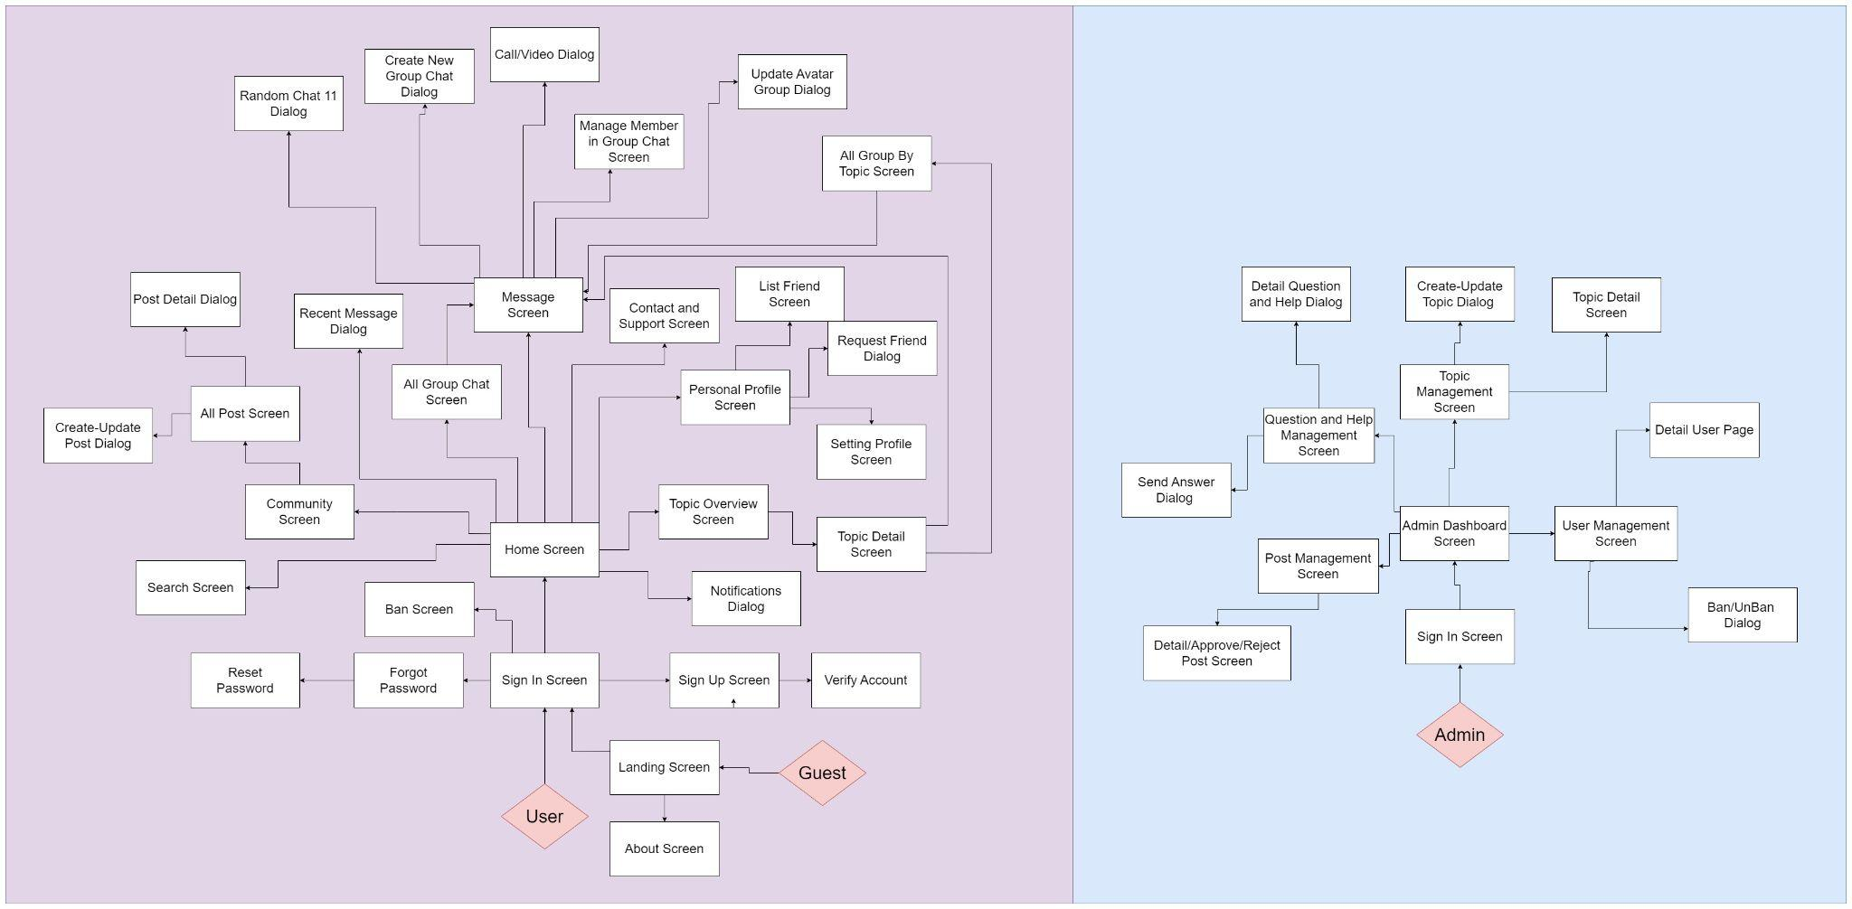

##### Figure 8. Screen Flows for each actor in TopicTalks Platform

#### 3.1.2 Screen Descriptions

| **#** | **Feature** | **Screen** | **Description** |
| --- | --- | --- | --- |
| 1 | Sign In | Sign in Screen | Provide the user the form to log in using their email/username and password . |
| 2 | Sign Up | Sign Up Screen | Provide user to register a new account. |
| 3 | Forgot Password | Forgot Password Screen | This feature is used for user enter email to reset password. |
| 4 | Reset Password | Reset Password Screen | This feature is used for users to enter password reset. |
| 5 | Landing Screen | Landing Screen | Display core information to encourage users to use the website. |
| 6 | Home Screen | Home Screen | A feature to display home page |
| 7 | New Feed | Community Screen | A feature to show all blogs of the website. |
| 8 | View Posts | All Post Screen | The screen displays the user's posts, it shows all the posts that the user has posted recently. |
| 9 | Create - Update Post | Create - Update Post Dialog | Dialog display feature to post or update posts. |
| 10 | View Post Detail | Post Detail Screen | The screen to display a full version of a blog that was created by another user. |
| 11 | View All Group Chat | All Group Chat Screen | The feature displays all chat groups about each subtopic currently on the system. |
| 12 | View Conversation | Conversation Screen | Features chat with friends, groups and random chat with strangers based on topics that the user is interested in. |
| 13 | Create New Group Chat | Create New Group Chat Dialog | Dialog displays the feature for users to create a new chat group about a defined topic. |
| 14 | Contact Admin | Contact and Support Screen | Feature that requires contacting the admin when having problems and needing admin help. |
| 15 | View Profile | Personal Profile Screen | This feature is used for users to view their profile. |
| 16 | View Friends List | List Friend Screen | This feature is used for users to view their friends list. |
| 17 | Setting Profile | Setting Profile Screen | This feature is used for users to set and edit their personal information. |
| 18 | View Topics | Topic Overview Screen | The feature displays all parent topics currently on the platform including child topics, and chat groups related to child topics. |
| 19 | View Details Of Topics | Topic Detail Screen | The screen displays child topics and chat groups related to that topic. |
| 20 | View Notifications | Notifications Dialog | The screen to display notification from admin. |
| 21 | View Admin’s Dashboard | Admin Dashboard Screen | The screen shows all basic information about TopicTalks system. |
| 22 | User Management | User Management Screen | A feature to display user’s information |
| 23 | View Detail User | Detail User Screen | User detailed information management feature. |
| 24 | Topic Management | Topic Management Screen | Feature to manage topics that admins have created on the platform |
| 25 | Topic Detail | Topic Detail Screen | Detailed management of trending topic rates based on topics admins have created on the platform. |
| 26 | Create - Update Topic | Create - Update Topic Dialog | Dialog display feature to topics or update topics. |
| 27 | Post Management | Post Management Page | Feature to manage all posts available on the platform. |
| 28 | Detail/ Approved Post | Detail/ Approved Post Screen | A feature to manage user comments in TopicTalks system and accept their blog or not. |
| 29 | Question Management | Question and Help Management Screen | Feature to manage questions that users have created and wait for admin to accept or not |
| 30 | Send Answer | Send Answer Dialog | Admin sends answers to questions that users have contacted. |
| 31 | Detail Question and Help | Detail Question and Help Dialog | Feature to view detailed questions related to the user's system. |
| 32 | Random Chat | Looking for partner Dialog | Feature to search for a chat person by topic randomly |
| 33 | Call/Video Call | Call/Video Call | Features for calling and video calling with friends |
| 34 | Manage Member in Group Chat | Manage Member in Group Chat Screen | Manage members in the group and perform tasks such as approving or rejecting members |
| 35 | Search | Search Screen | Feature used to search for favorite topics |
| 36 | Ban Screen | Ban Screen | User who violate the system's rules will be banned by the admin and display that screen when trying to login |

#### Table 3. Screen Descriptions

#### 3.1.3 Screen Authorization

| **Screen** | **User** | **Admin** | **Guest** | **Host Group** |
| --- | --- | --- | --- | --- |
| Sign In | X | X |  | X |
| Sign Up | X | X | X | X |
| Forgot Password | X | X |  | X |
| Landing Page | x | X | X | X |
| Homepage | X |  |  | X |
| Recent Message Box | X |  |  | X |
| Topic Overview | x |  |  | X |
| Topic Detail | X |  |  | X |
| All Posts | X |  |  | X |
| Post Detail | X |  |  | X |
| All Group Chat | X |  |  | X |
| Random Chat | X |  |  | X |
| Create New Group Chat | X |  |  | X |
| Approve/ Reject Member Join Group Chat |  |  |  | X |
| Group Chat | X |  |  | X |
| Chat with friends | X |  |  | X |
| Chat with strangers | X |  |  | X |
| Contact Us | X |  |  | x |
| Personal Profile | X |  |  | X |
| Friend List | X |  |  | X |
| Friend Request List | X |  |  | X |
| Update Profile | X |  |  | X |
| Notifications | X |  |  | x |
| Admin Dashboard |  | X |  |  |
| Admin’s User |  | X |  |  |
| Admin’s Topic |  | X |  |  |
| Admin’s Post |  | X |  |  |
| Admin’s FAQ |  | X |  |  |

#### Table 4. Screen Authorization

#### 3.1.4 Non-Screen Functions

| **#** | **Feature** | **System Function** | **Description** |
| --- | --- | --- | --- |
| 1 | Email Sending | Sign up | When a user registers, a confirmation code will be sent via email to verify the email. |
| 2 | Forgot Password | When the user wants to recover the password, the password reset link will be sent via email. |
| 3 | Upload Image Service | Create Topic | When a user makes a topic creation with photos, the upload image service will run in background to handle the photo. |
| 4 | Create Post | When a user creates a post with photos, the upload image service will run in background to handle the photo. |
| 5 | Authorization | Function for User and Admin | All requests to User and Admin functions are passed through the user authorization middleware. |

#### Table 5. Non-Screen Functions

#### 3.1.5 Entity Relationship Diagram

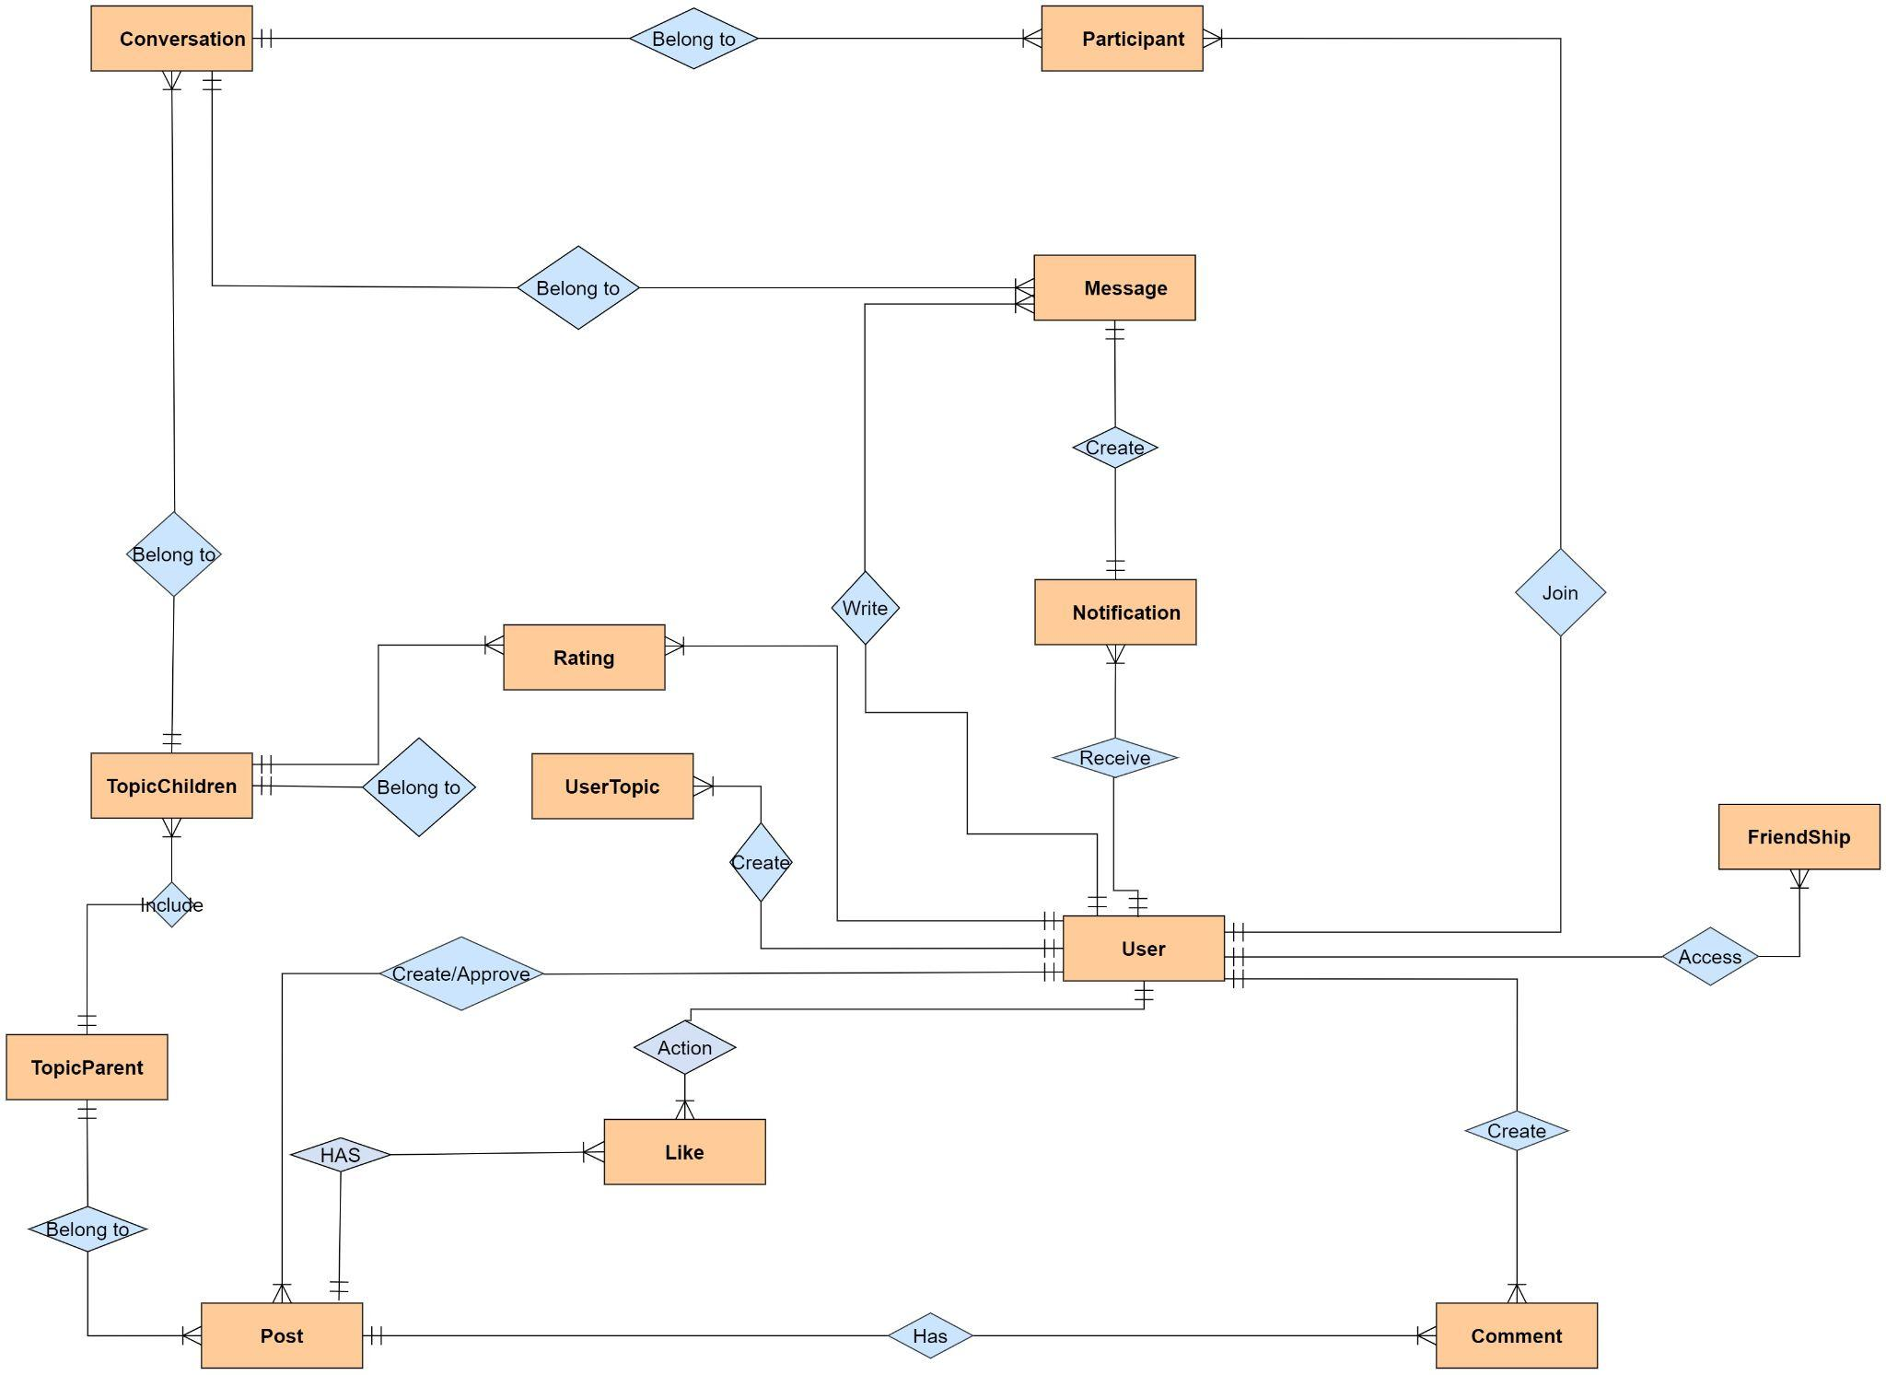

##### Figure 8. Entity Relationship Diagram

**Entities Description**

| **#** | **Entity** | **Description** |
| --- | --- | --- |
| 1 | User | Store user information in the TopicTalks system.  - Properties:   * user_id (Primary Key) * username * password * full_name * profile_img * phone_number * isAdmin * created_at * ban_date * email * refresh_token * country * dob |
| 2 | Friend Ship | User can make friends with others and view their friends list.  - Properties:   * id (Primary Key) * User_id (Foreign Key) * userRequested_id * access_status * isPublic |
| 3 | UserTopic | Store topics that users are interested in.  - Properties:   * topic_id (Foreign Key) * user_id (Foreign Key) |
| 4 | TopicChildren | Child topics are created based on the parent topic. Includes posts and conversations related to this child topic.  - Properties:   * topic_id (Primary Key) * tparent_id (Foreign Key) * name * created_at * url_image |
| 5 | TopicParent | Topics currently in the system, including subtopics related to this topic.  - Properties:   * tparent_id (Primary Key) * tparent_name * created_at |
| 6 | Conversation | Manage conversations (chat 1:1, group, friends) with a general topic of conversation.  - Properties:   * conversation_id (Primary Key) * topic_id (Foreign Key) * chatName * isGroupChat * admin_id |
| 7 | Post | User can create topic posts to discuss with other users on the site.  - Properties:   * post_id (Primary Key) * author_id is Foreign Key * topic_id (Foreign Key) * title * isApproved * content * created_at * image |
| 8 | Message | Manage all outgoing and incoming messages for users.  - Properties:   * mess_id (Primary Key) * sender_id (Foreign Key) * conversation_id (Foreign Key) * content * sent_at |
| 9 | Participant | Manage member participation in each conversation.  - Properties:   * conversation_id (Foreign Key) * user_id (Foreign Key) * isMember |
| 10 | Notification | Store user notifications such as user’ like, comments or friend request.  - Properties:   * notifi_id (Primary Key) * user_id (Foreign Key) * message_id (Foreign Key) * atTime * read_status |
| 11 | Comment | The comment section belongs to each post of each topic. User can create comments to express their opinions or questions after viewing the post.  - Properties:   * id (Primary Key) * user_id (Foreign Key) * id_post (Foreign Key) * content * created_at |
| 12 | Like | Likes belong to each post of each topic, users can like posts to show they are interested in posts about this topic.  - Properties:   * user_id (Foreign Key) * post_id (Foreign Key) |
| 13 | Rating | Rating is used so that users can evaluate topics according to personal opinions, thereby selecting hot topics and recommending them to other users. - Properties:  + topic_children_id (Foreign Key)  + user_id (Foreign Key)  + rating |

#### Table 6. Entities Description

### **3.2 Authentication**

#### 3.2.1 Sign In

* Function trigger: User clicks on the "SIGN IN" button on the homepage or accesses the sign-in page with a link.
* Screen layout:  
  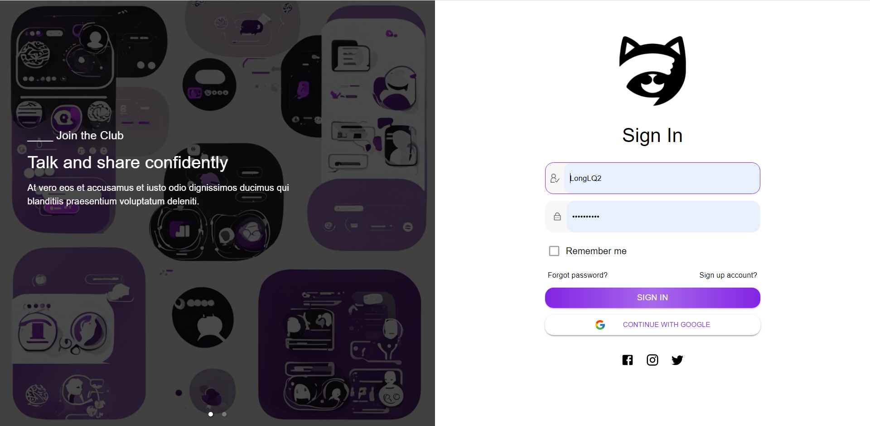

##### Figure 9. Sign-In Screen

* Function Details:
* Validations: The password must meet minimum requirements such as length, and character types.
* Functionalities: The system checks if required login information is filled, then checks for account existence and password correctness. It allows login with correct credentials

#### 3.2.2 Sign Up

* Function trigger: User clicks on the "Sign up account?" link in the Sign in page or accesses the signup page with a link.
* Screen layout:  
  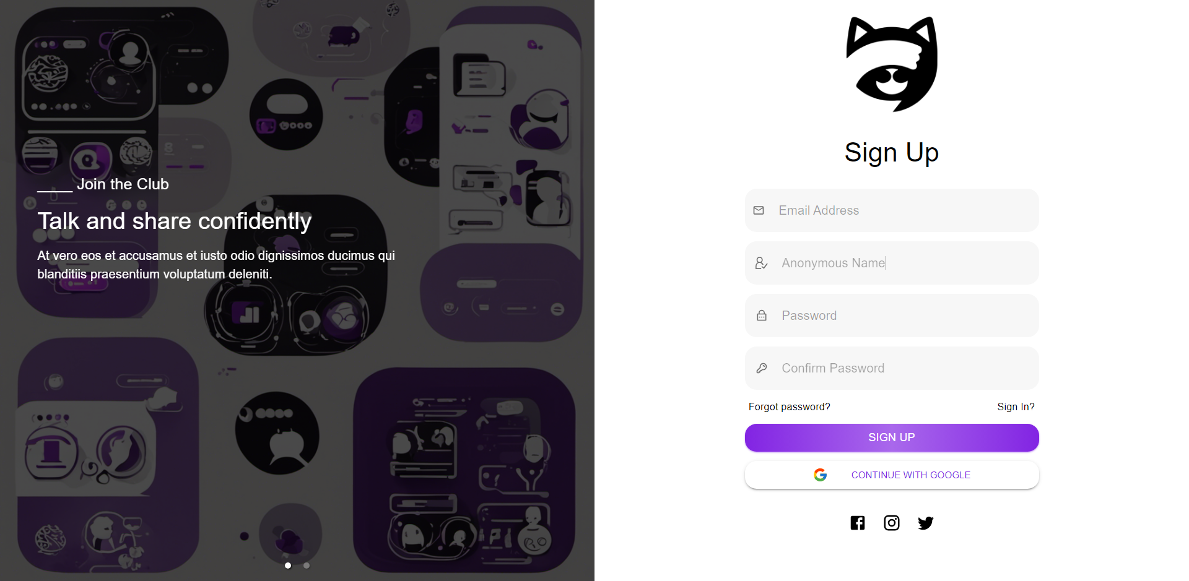

##### Figure 10. Sign Up Screen

* Function Details:
* Validations: All fields are required, and the email address and password should be in a valid format.
* Functionalities: The system checks if all required registration information is filled, then checks for account and email existence. It allows registration and login if all requirements are met, or asks for re-entry if fields do not match.

#### 3.2.3 Forgot, Reset Password

#### Function trigger: User clicks on the "Forgot password?" link on the login screen.

* Screen layout:  
  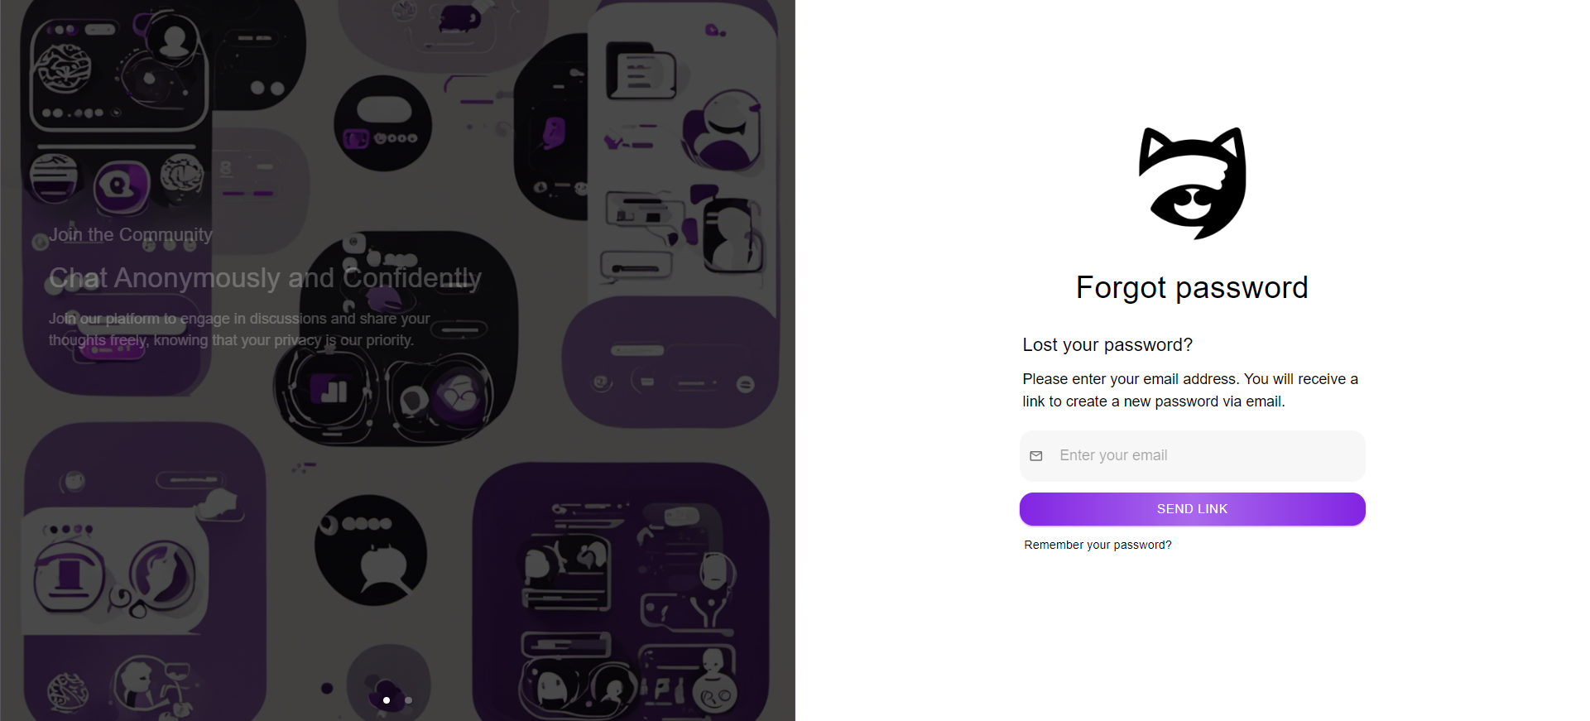

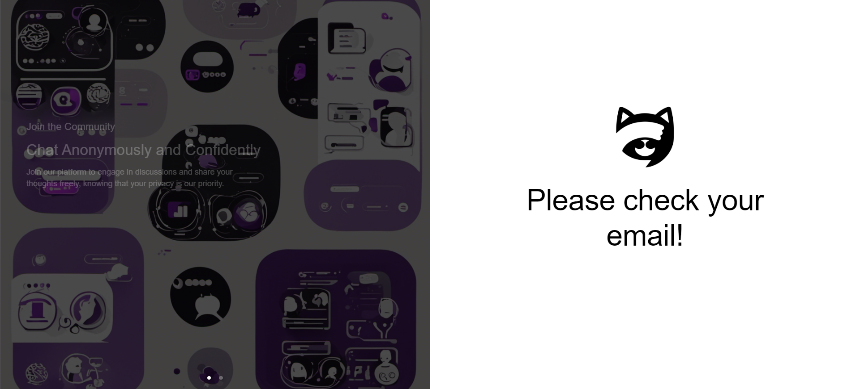

##### Figure 11. Forgot Password Screen

* Function Details:
* Validation: The email address entered by the user exists in the system. The email sent to the user contains a secure link to reset their password that expires after a certain time period.
* Functionalities: This page allows users to reset their forgotten password by verifying their email address. User can enter their registered email address and follow the instructions in the email to set a new password.

#### 3.2.4 Reset Password

#### Function trigger: User enter new password and confirm new password on the login screen.

* Screen layout:  
  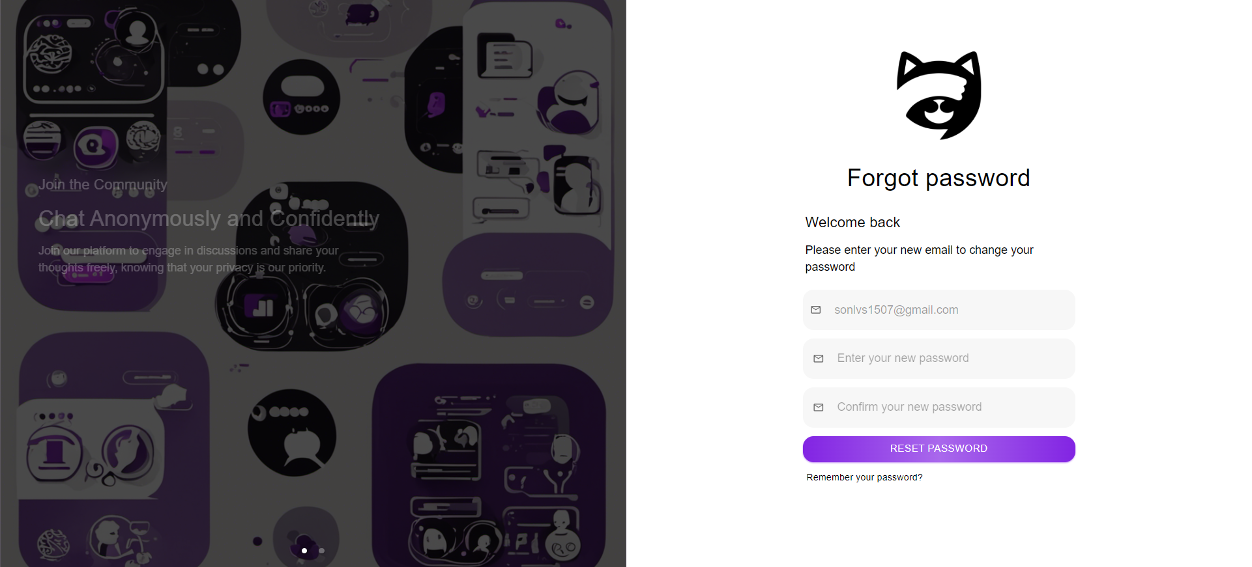

##### Figure 12. Reset Password Screen

* Function Details:
* Functionalities: This page allows people to reset their password. An error message is displayed if the entered new password and confirmed new password do not match.

### **3.3 Landing Page**

#### 3.3.1 Landing Page

#### Function trigger: The "View landing page" function is triggered when the user visits a website link.

* Screen layout:  
  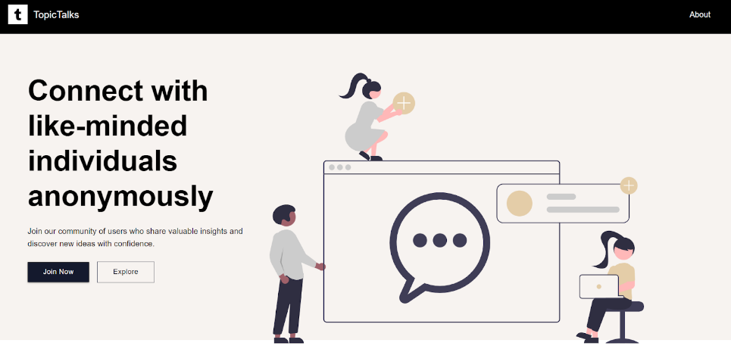

##### Figure 13. Landing Page Screen

* Function Details:
* Functionalities: This function displays core information to encourage users to use the website.

### **3.4 Home Page**

#### 3.4.1 Home Page

#### Function trigger: The "View Home Page" function is activated when the user successfully logs into the system or clicks on the FLearning logo in the website to display the home page.

* Screen layout:

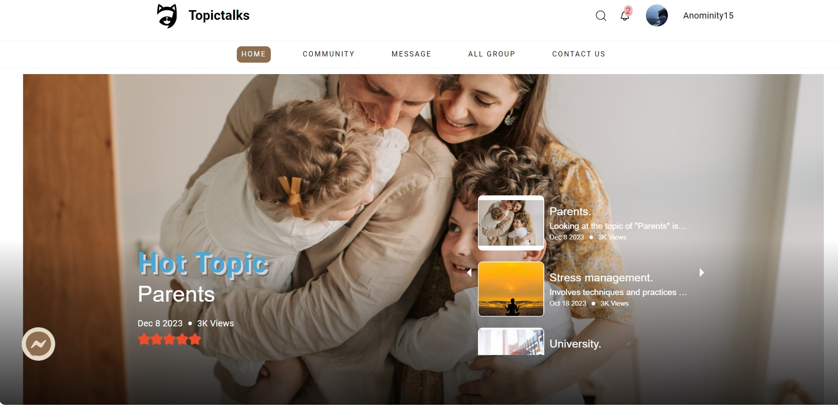

##### Figure 14. Home Page Screen

* Function Details:
* Functionalities: This function displays the home page including hot topics, recommended topics, popular articles and navigation menu and topic search function.

### **3.5 User Profile**

#### 3.5.1 Personal Profile

#### Function trigger: The "View Personal Profile" function is triggered when the user login to the TopicTalks website and go to my profile page.

* Screen layout:  
  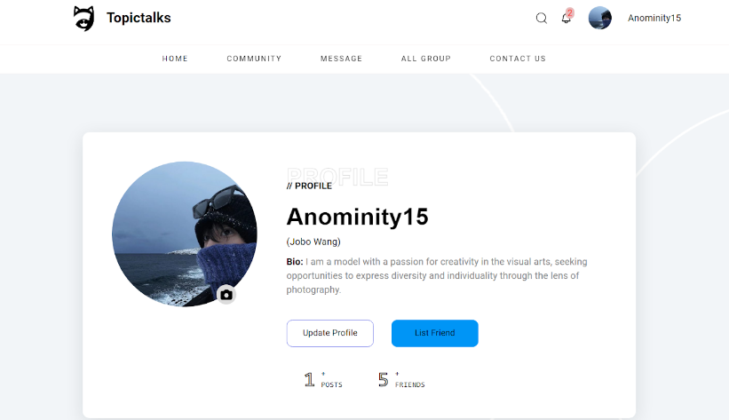

##### Figure 15. Personal Profile Screen

* Function Details:
* Functionalities: This screen displays the user's profile information including their name, bio, and Profile Photo.

#### 3.5.2 List Friend

* Function trigger: The "View friends list" function is activated when the user navigates to the personal information page.
* Screen layout:

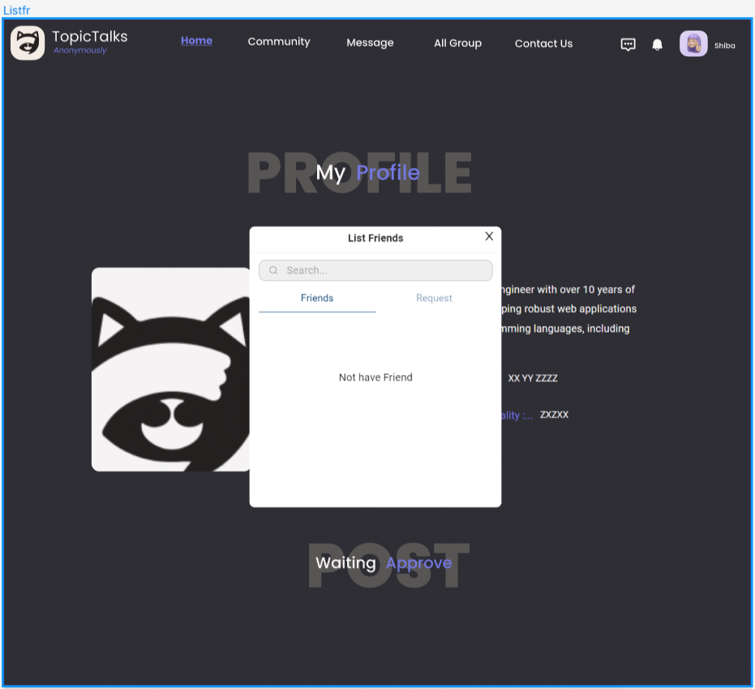

##### Figure 16. List Friend Screen

* Function Details:
* Functionalities: This screen displays a list of friends and a list of sent friend requests waiting to be accepted by the user.

#### 3.5.3 Setting Profile

* Function trigger: Users click "Update Profile" on their profile.
* Screen layout:

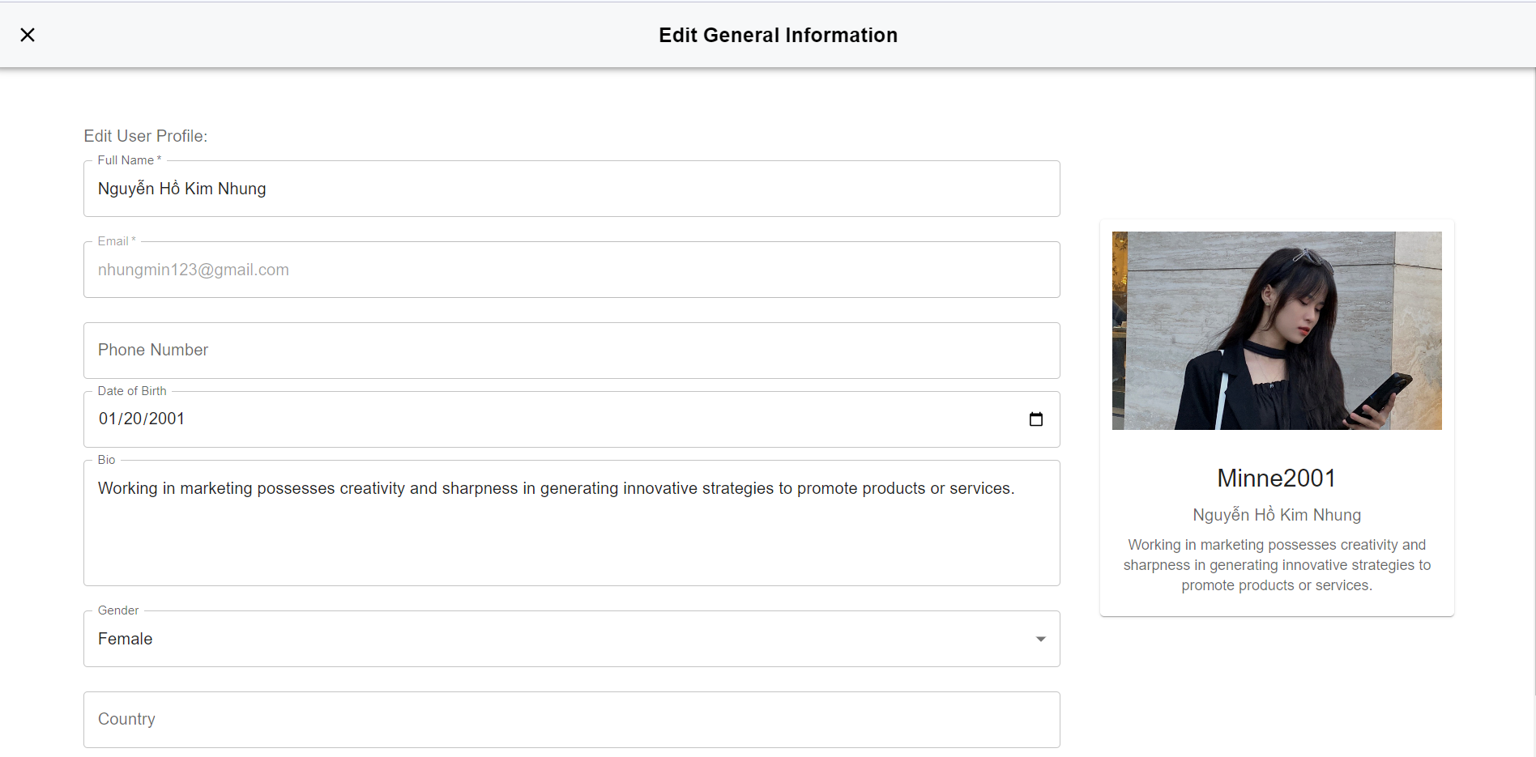

##### Figure 17. Setting Profile Screen

* Function Details:
* Functionalities: This screen displays the user's profile information including their name, Phone number, bio, and so on. Users can edit their profile information.

### **3.6 Topic**

#### 3.6.1 Topic Overview

#### Function trigger: On the Homepage, users can see its parent topics and child topics.

* Screen layout:  
  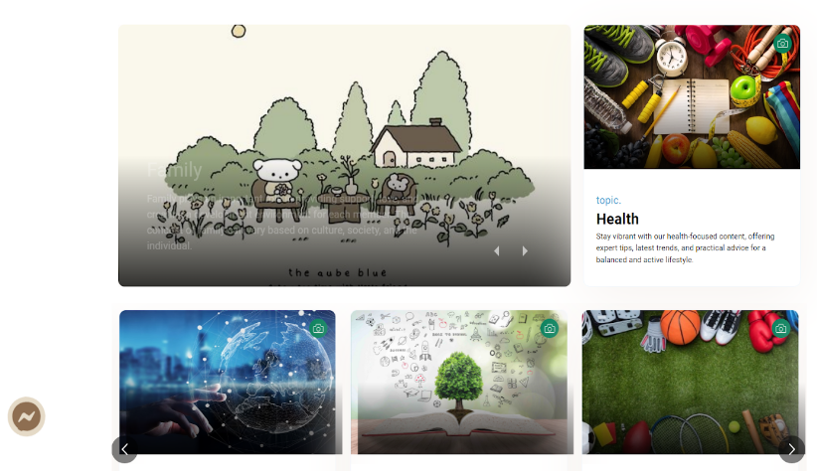

##### Figure 16. Topic Overview Screen

* Function Details:
* Functionalities: Overview page of current topics on the system. The screen displays the parent topic name and descriptive image. If the theme is not available, an error message will be displayed.

#### 3.6.2 Topic Detail

#### Function trigger: Users click on any parent topic and select a child topic to see a description of that topic.

* Screen layout:  
  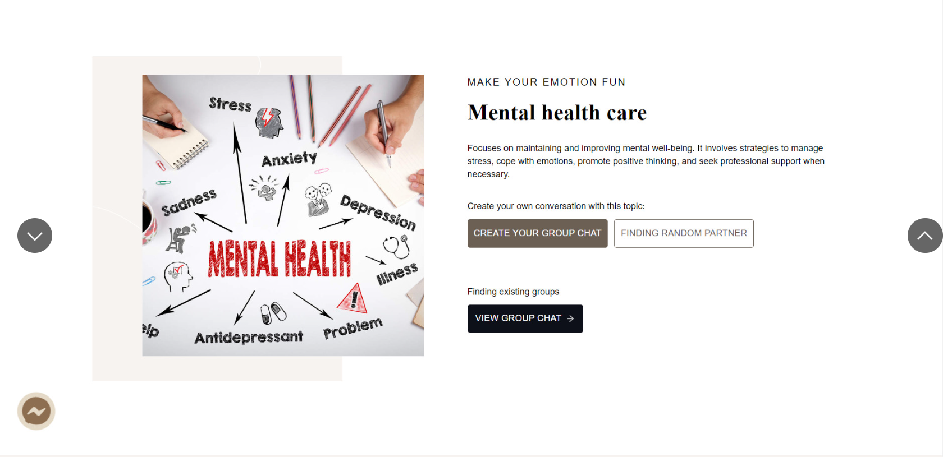

##### Figure 17. Topic Detail Screen

* Function Details:
* Functionalities: On this page, users can view the description of the topic, rate the topic, create a chat group or find a random partner to chat about this topic.

### **3.7 Recent Message Box**

#### 3.7.1 Recent Message Box

#### Function trigger: Users click on the "Message Box" icon on any page to view the most recent messages in condensed form.

* Screen layout:  
  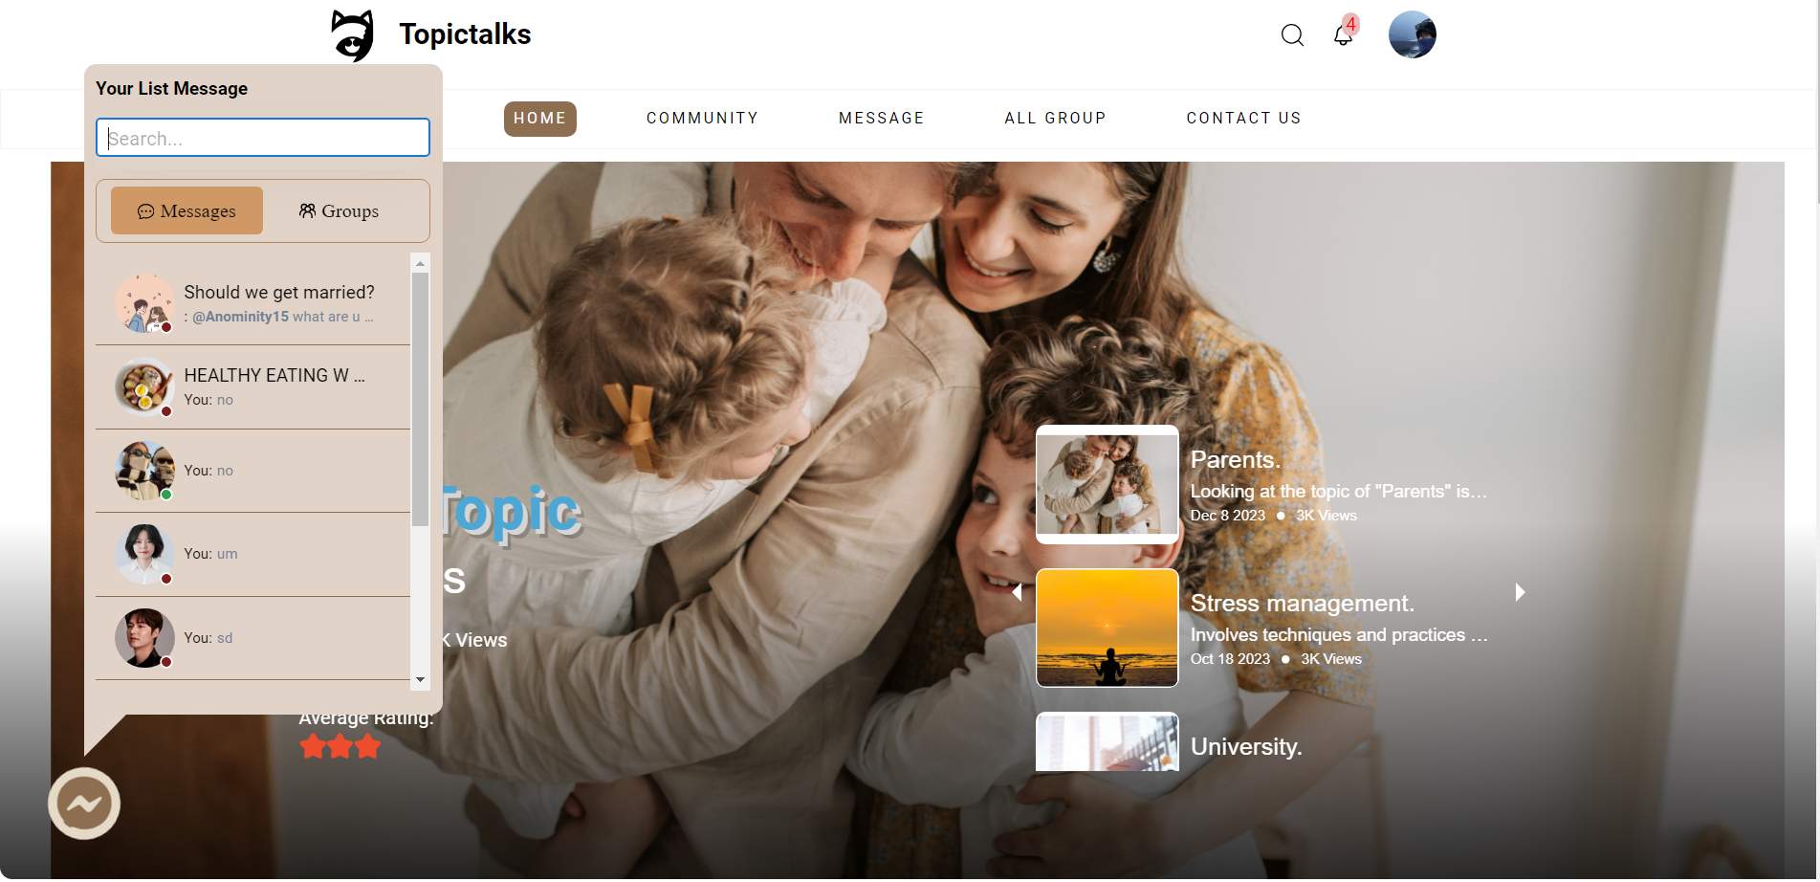

##### Figure 18.Recent Message Box Screen

* Function Details:
* Functionalities: In this miniature chat box, users can view recent conversations, click on any chat to go to the Message page.

### **3.8 Community**

#### 3.8.1 All Posts

* Function trigger: This function is activated when the user visits the home page and clicks the “COMMUNITY” button on the menu bar.
* Screen layout:

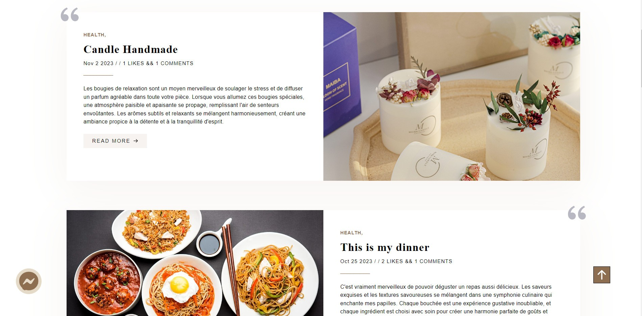

##### Figure 19. All Posts Screen

* Function Details:
* Functionalities: This page displays all posts about every topic available on the system.

#### 3.8.2 Post Detail

* Function trigger: This function is activated when the user visits the homepage and clicks the "Read more" button on any post on the COMMUNITY page.
* Screen layout:

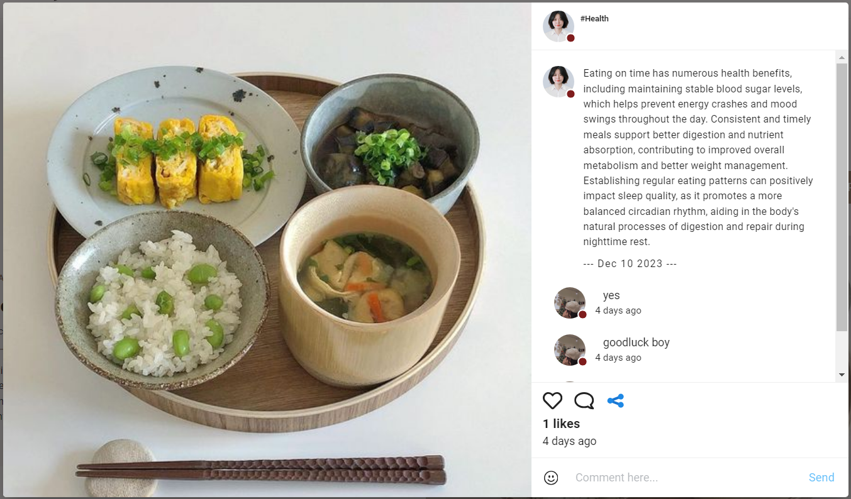

##### Figure 20. Post Detail Screen

* Function Details:
* Functionalities: This page allows users to view post details including information such as author, subject, comments and more.

### **3.9 All Group Chat**

#### 3.9.1 All Group Chat

* Function trigger: This function is activated when the user visits the home page and clicks the “ALL GROUP CHAT” button on the menu bar.
* Screen layout:

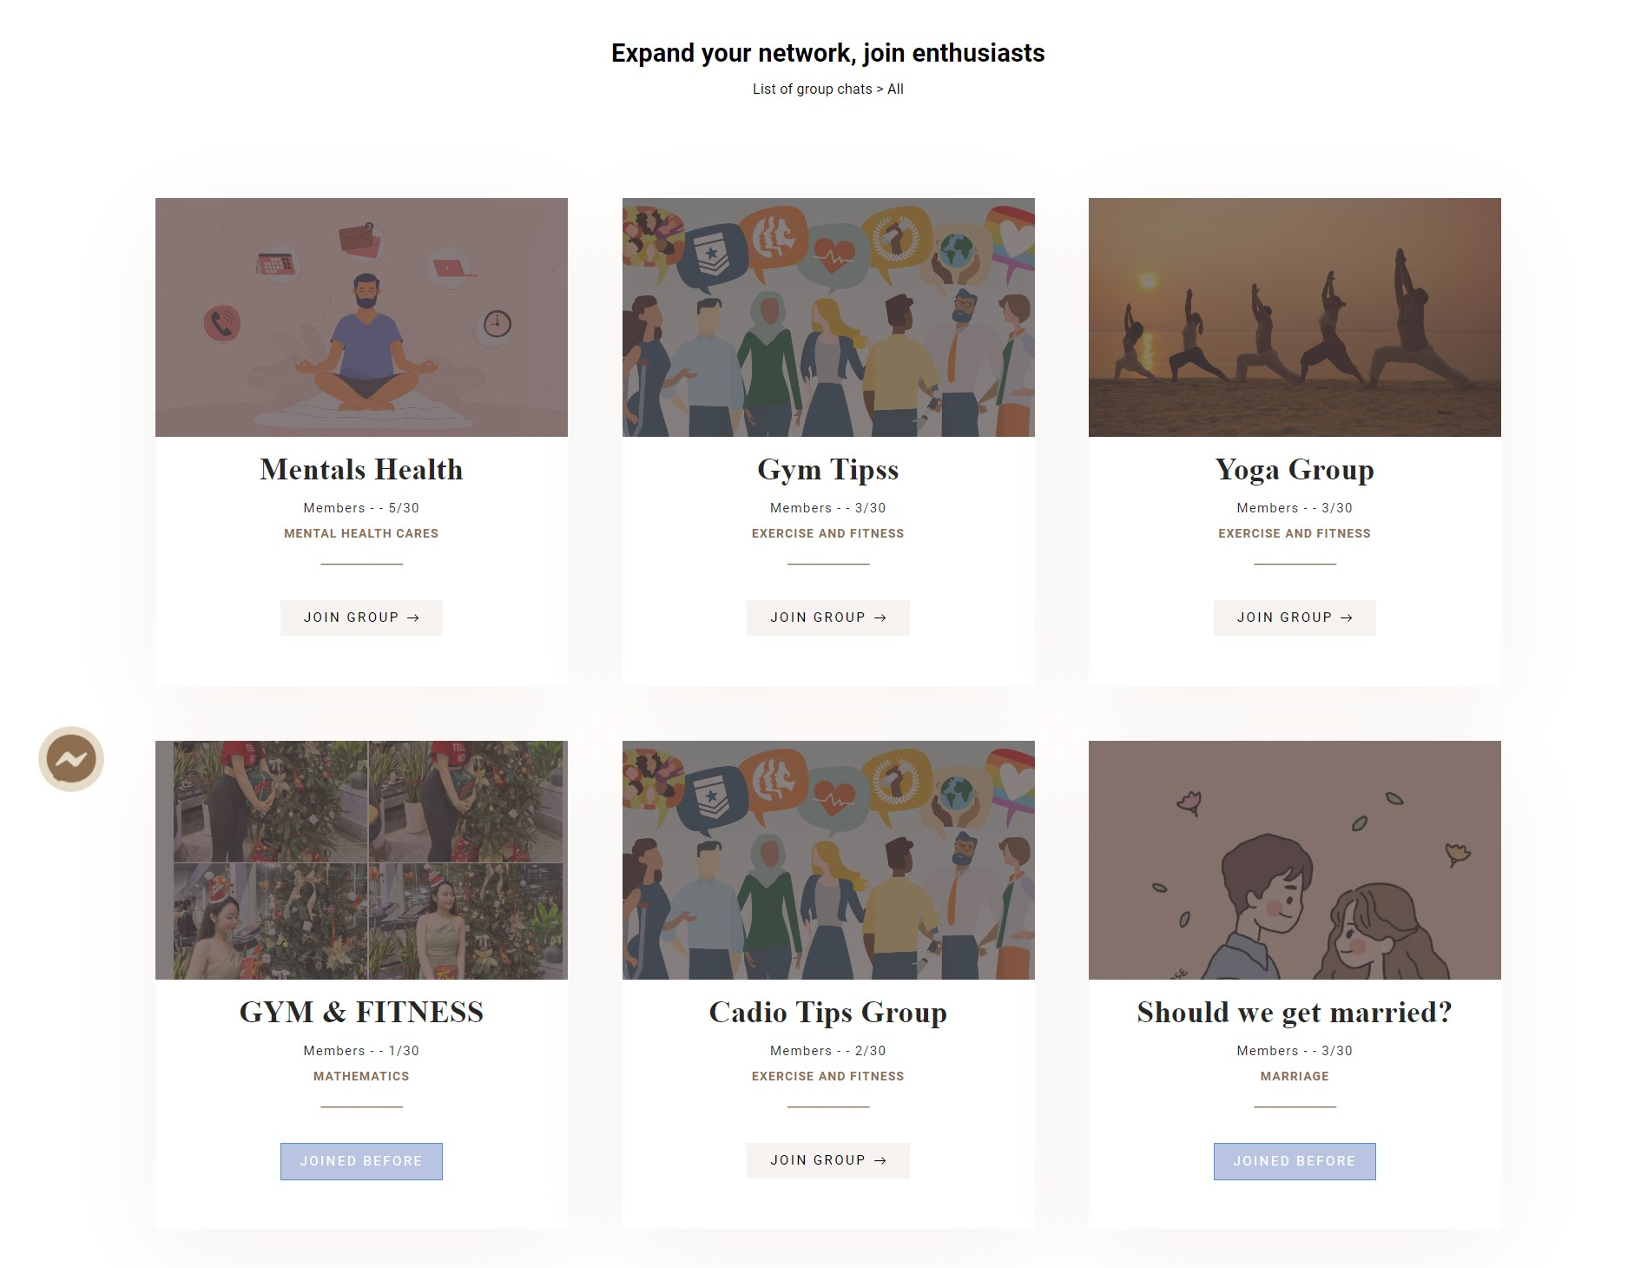

##### Figure 21. All Group Chat Screen

* Function Details:
* Functionalities: The system displays existing chat groups and the user clicks the "JOIN GROUP" button to join the conversation.

#### 3.9.2 Create New Group Chat

* Function trigger: Users click the "Create Chat Group" icon to create a chat group by topic.
* Screen layout:

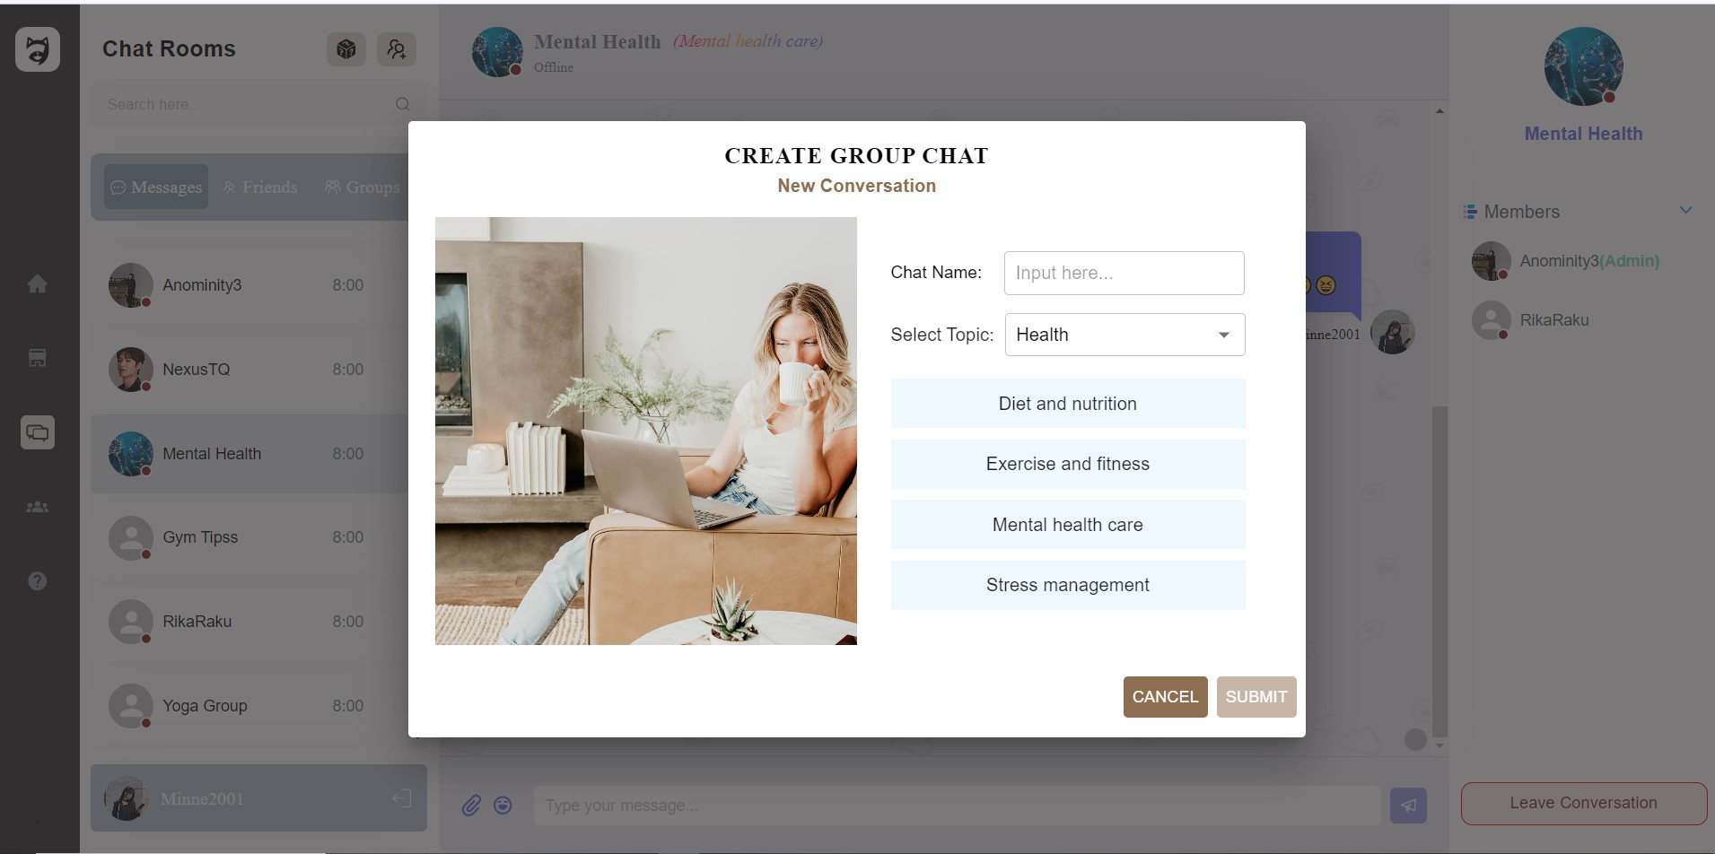

##### Figure 22. Create New Group Chat

* Function Details:
* Functionalities: Create a chat group to gather many people to talk about a selected topic.

### **3.10 Conversation**

#### 3.10.1 Conversation

* Function trigger: This function is activated when the user visits the homepage and clicks the “Message” button in the menu bar.
* Screen layout:

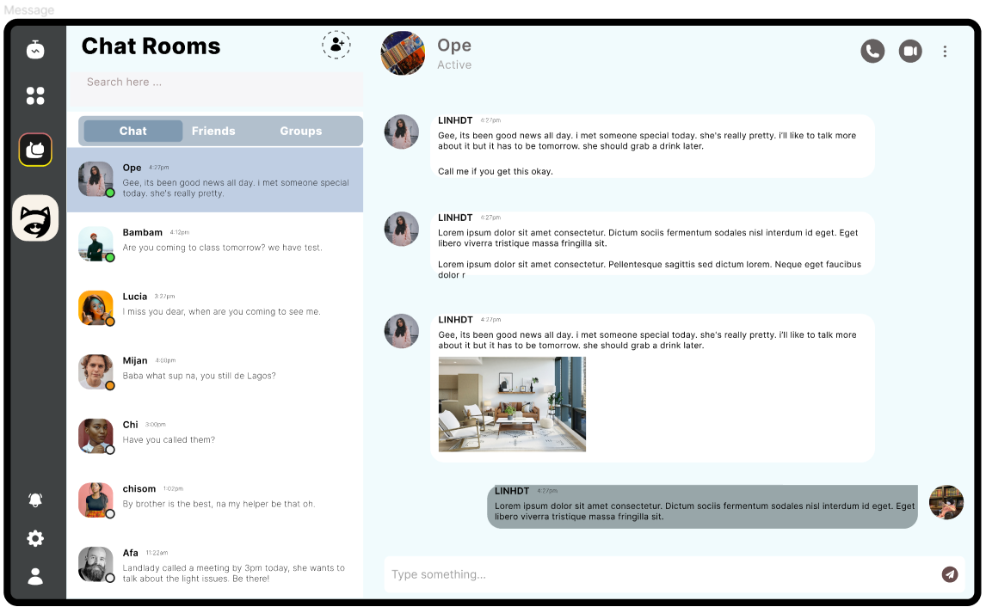

##### Figure 23. Conversation Screen

* Function Details:
* Functionalities: This page displays all chats including (group chat, chat with friends), and chat function with a random person that shares the same topic that the user is interested in.

#### 3.11 Notifications

#### 3.11.1 Notifications

* Function trigger: This function is activated when the user visits the homepage and clicks on the "Bell" icon on the homepage.
* Screen layout:

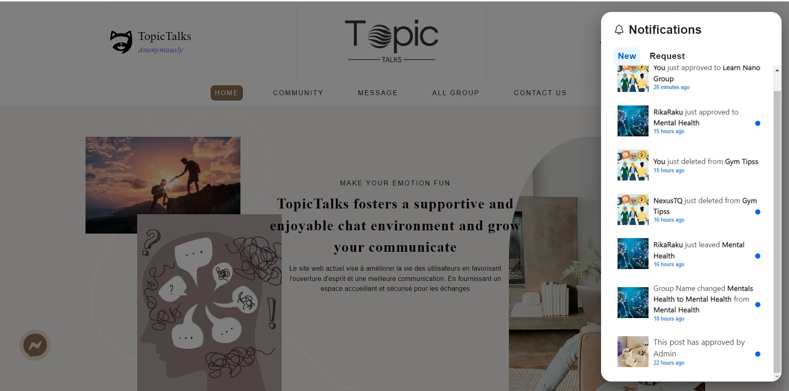

##### Figure 24. Notification Screen

* Function Details:
* Functionalities: The dialog shows all types of notifications sent to the user.

### **3.12 Contact Us**

#### 3.12.1 Contact Us

* Function trigger: This function is activated when the user visits the homepage and clicks the “CONTACT US” button in the menu bar.
* Screen layout:

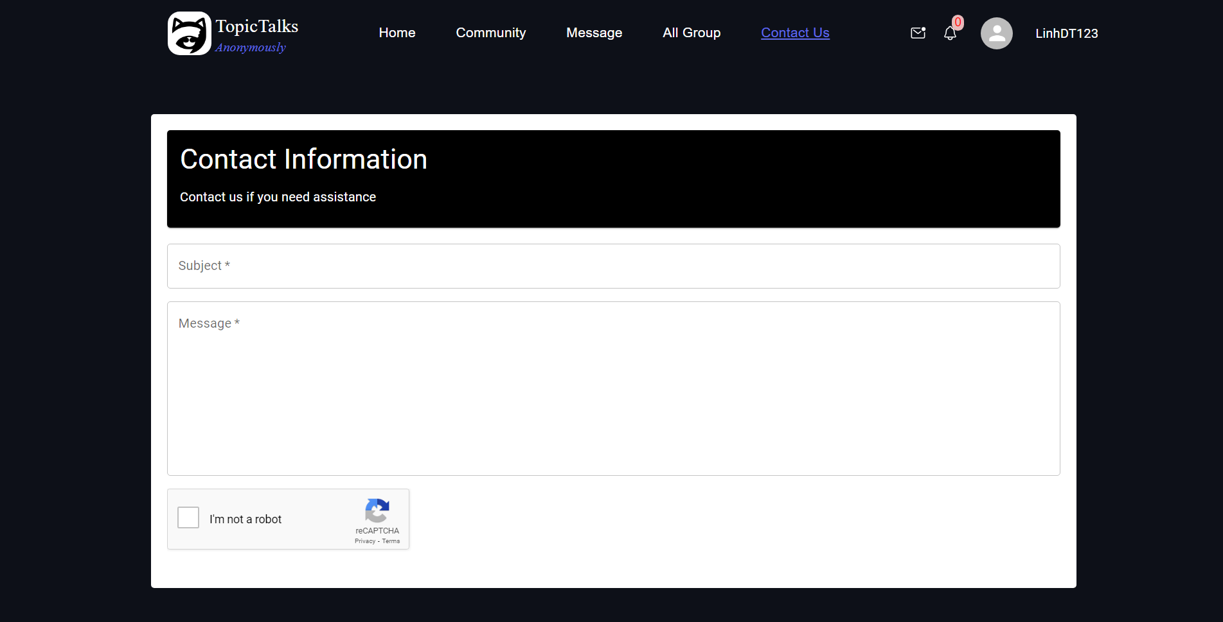

##### Figure 25. Contact Us Screen

* Function Details:
* Functionalities: This screen allows users to submit questions to the system.

#### 3.13 Admin Analyst Data 3.13.1 Admin Dashboard

* Function trigger: The user logs in with the admin account to go to the Dashboard page.
* Screen layout:

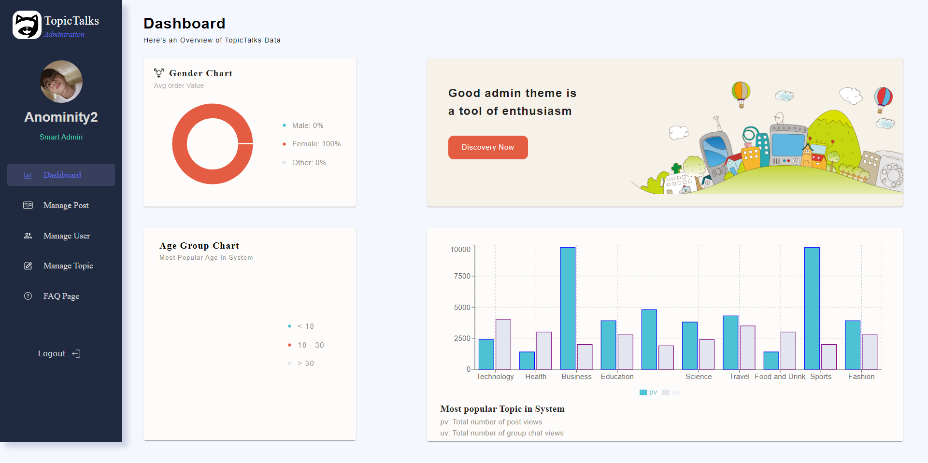

##### Figure 26. Dashboard Screen

* Function Details:
* Validation: Only the user who logs in to an Admin role can use this function.
* Functionalities: On this page, users can see an overview of the TopicTalks System's properties such as total number of topics, average age, and gender of users participating in the system.

#### 3.13.2 Admin's User

* Function trigger: User clicks the tab “Manage User” in the sidebar.
* Screen layout:

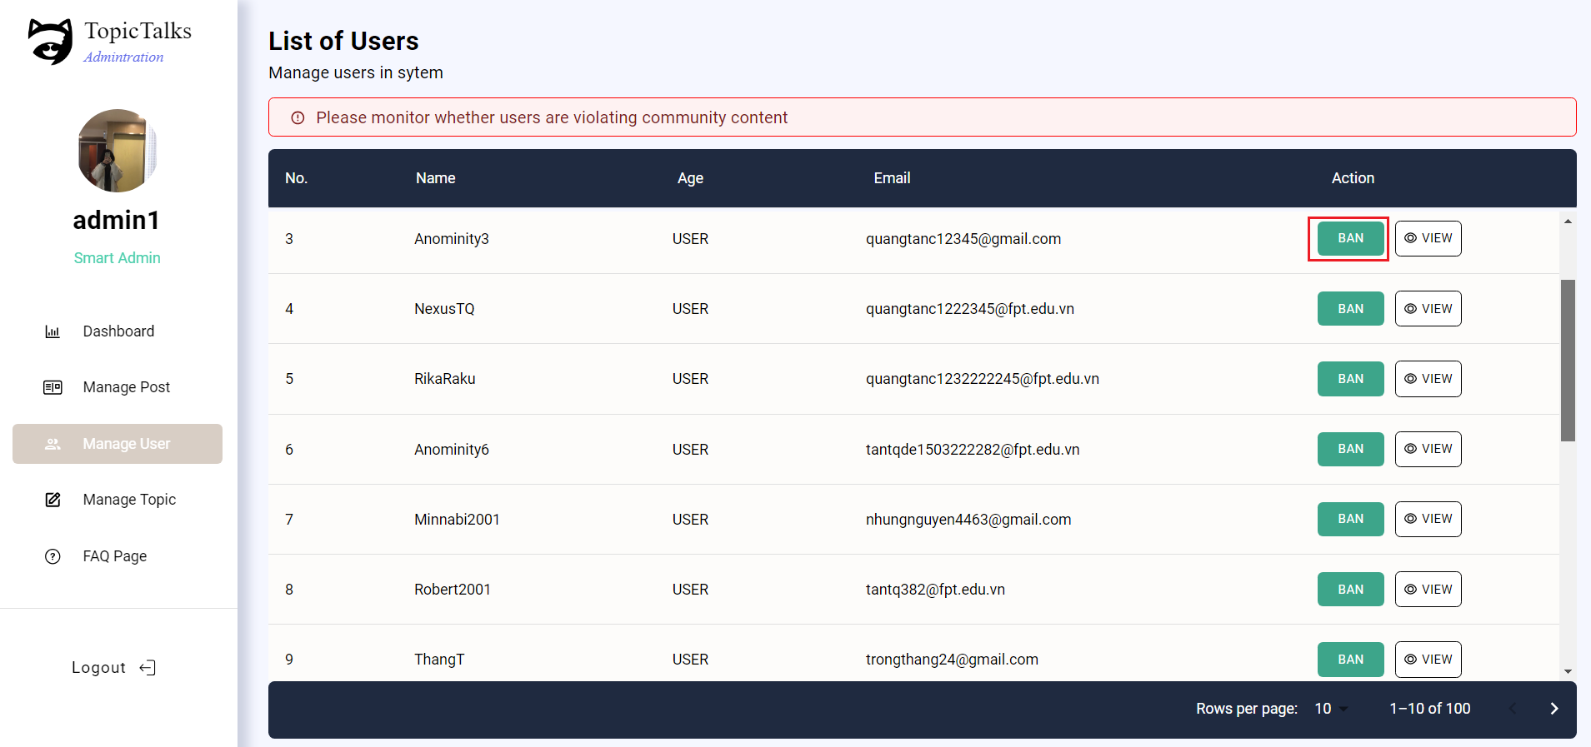

##### Figure 27. Admin’s User Screen

* Function Details:
* Validation: Only the user who logs in to an Admin role can use this function.
* Functionalities: On this page, users can control the information of all users in the TopicTalks system by viewing some attributes such as user personal information, ban or unban users.

#### 3.13.3 Admin's Topic

* Function trigger: User clicks the tab “Manage Topic” in the sidebar.
* Screen layout:

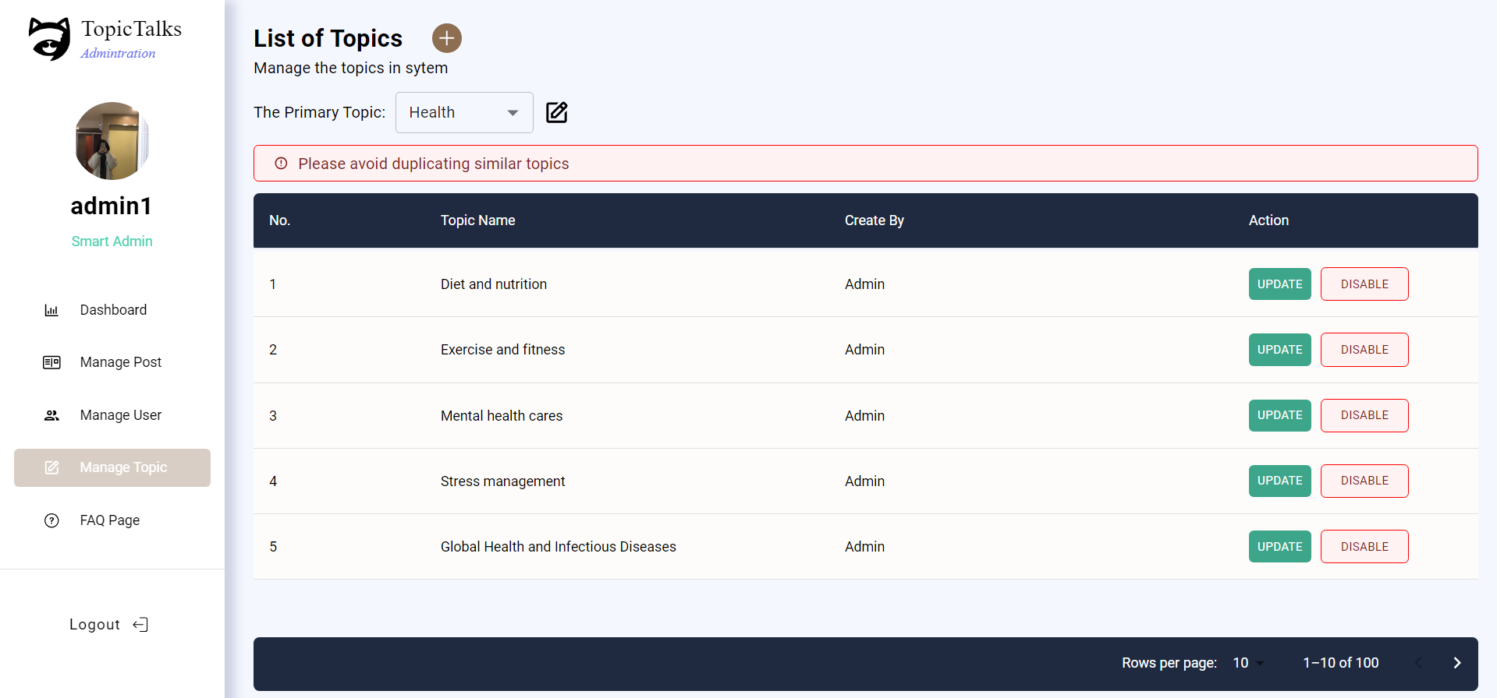

##### Figure 28. Admin’s Topic Screen

* Function Details:
* Validation: Only the user who logs in to an Admin role can use this function.
* Functionalities: On this page, users can control existing topics in the TopicTalks system including its child topics.

#### 3.13.4 Admin’s Post

* Function trigger: User clicks the tab “Manage Post” in the sidebar.
* Screen layout:

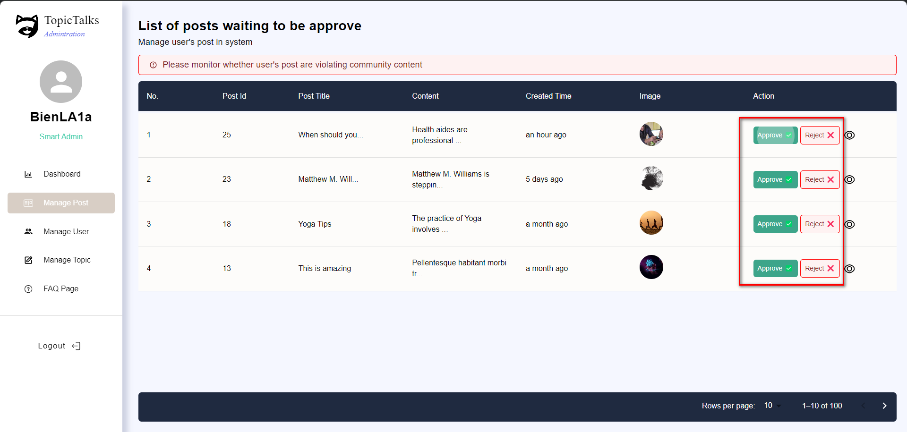

##### Figure 29. Admin’s Post Screen

* Function Details:
* Validation: Only the user who logs in to an Admin role can use this function.
* Functionalities: On this page, users can control users' posts in the TopicTalks system by previewing posts and approving or rejecting posts.

#### 3.13.5 Admin’s FAQ

* Function trigger: User clicks the tab “FAQ Page” in the sidebar.
* Screen layout:

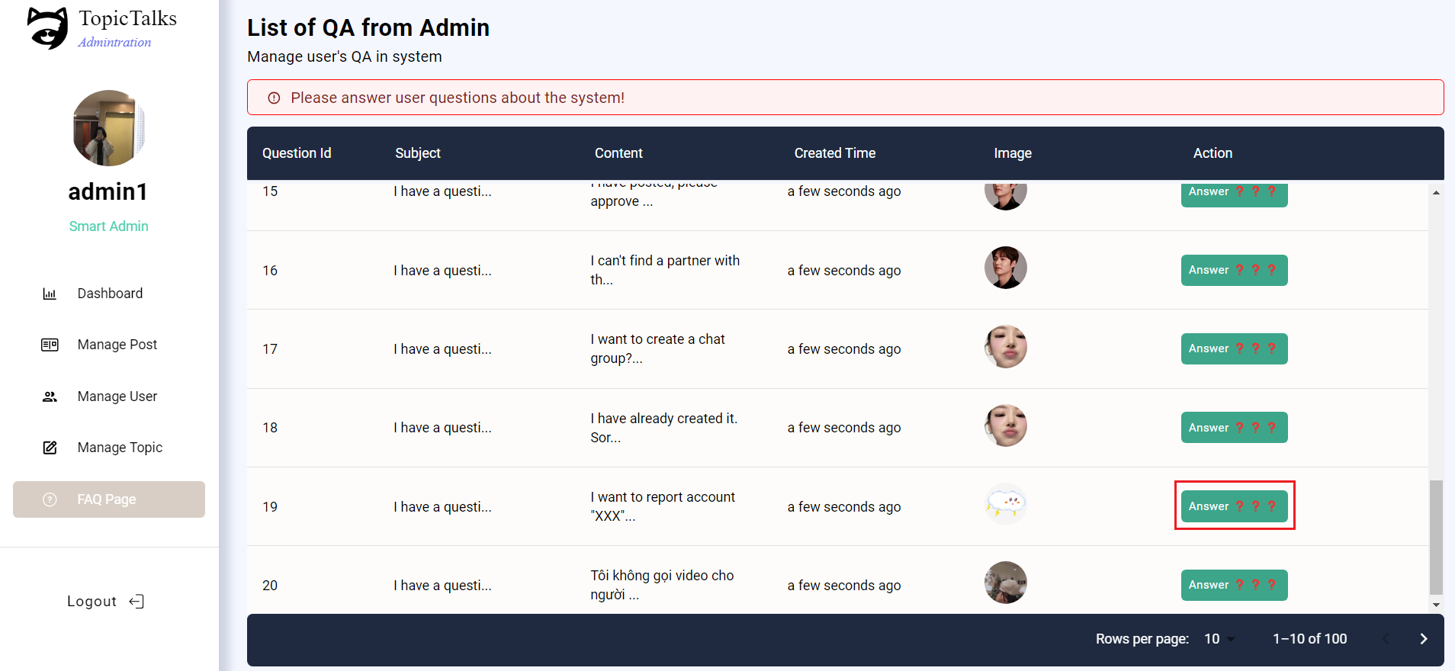

##### Figure 30. Admin’s FAQ Screen

* Function Details:
* Validation: Only the user who logs in to an Admin role can use this function.
* Functionalities: On this page, users can control the questions available in the TopicTalks system and send feedback to users' questions.

## **Non-Functional Requirements**

### **4.1. External Interfaces**

#### 4.1.1 User Interface

* UI-01: The system must display a Success Message or Error Message when completing an action.
* UI-02: When the user is doing the Delete option, there must be a Confirm (Y/N) dialog.
* UI-04: All pages in the system must have a Header menu and a Navigation menu.

#### *4.1.2 Software Interface*

* SI-01: User can use Google services as Login, which will help them to authenticate their account.

#### 4.1.3 Hardware Interface

* N/A

### **4.2. Quality Attributes**

#### 4.2.1 Availability

* The TopicTalks Platform should be accessible at least 95% of the time.
* The TopicTalks Platform is accessible 24/7 from Monday to Sunday, except for the maintenance hours of 23:00-24:00 on Sundays.

#### 4.2.2 Usability

* The interface must be simple and easy to use.
* The interface must be intuitive and user-friendly, ensuring that users can easily navigate and interact with the platform.

#### 4.2.3 Reliability

* The server should run at least 22 hours daily, to ensure users can access the platform reliably.

#### 4.2.4 Performance

* Response time for a request to host: 1 second, ensuring a smooth and responsive user experience
* Chat between users with a delay of <1 second, maintaining real-time communication
* Uploads of large images (>20 MB) should be complete processing after 3s.

#### Data backup should be performed every month.

#### 4.2.5 Security

* All queries made to SQL must be escaped so no SQL Injection
* The platform should implement appropriate security measures to protect user identities and ensure anonymous chatting remains confidential

#### 4.2.6 Maintainability and Extensibility

* The project's documentation should be stored in a concise and organised manner so that it can be easily retrieved when needed.

## **Requirement Appendix**

### **5.1 Business Rules**

| **#** | **Rule Definition** |
| --- | --- |
| BR-01 | The email password reset link will expire after 20 minutes. |
| BR-02 | Password regulations: at least 8 characters, must include at least 1 uppercase letter, 1 lowercase letter, 1 number and 1 special character. |
| BR-03 | Only one account can be created per email account. |
| BR-04 | Passwords stored in the database must be hashed by the Bcrypt algorithm. |
| BR-05 | User cannot edit their username and email. |
| BR-06 | Only the user's friends can see posts displayed on the user's profile. |
| BR-07 | When a user wants to post, they must be approved by the administrator. |
| BR-08 | All deleting actions must have a confirmation popup before deleting. |
| BR-09 | The TopicTalks platform must have a system to handle user disputes and complaints about the content of other users' blogs, or other issues. |
| BR-10 | The TopicTalks Platform must maintain the privacy and security of user data and not use it for any other purpose. |
| BR-11 | The TopicTalks Platform must have a user-friendly interface, allowing users to easily search and join chat groups. |
| BR-12 | The TopicTalks Platform must support different types of multimedia content, including images, and text. |
| BR-13 | Only admins can add/edit/disable topics. |
| BR-14 | Only the user's friends can make calls and video calls to each other. |
| BR-15 | If the chat group has enough members, it will be impossible to join the group. |
| BR-16 | The TopicTalks server system must have an operating rate of 95% in a month, the average time to fix any issues causing downtime must be 6 hours. |
| BR-17 | All update actions must have a confirmation popup before updating. |
| BR-18 | Users can only edit posts when the post is waiting for admin approval. |

#### Table 7. Business Rule

### **5.2 Common Requirements**

| **#** | **Requirement** | **Description** |
| --- | --- | --- |
| 1 | Objective | Recommended topics on the web must fulfill an intended purpose, such as providing chat group quality information on a specific topic to users. |
| 2 | Functionality | Web chats must provide basic multimedia functions such as video calling, audio, image and text sending. |
| 3 | User interface design | The website must be designed uniformly, limiting the use of too many colors that distract from the topics that users are interested in. In particular, the chat page design does not have distracting things such as ads. |
| 4 | Security | The web platform needs to ensure the security of all user information. |
| 5 | Responsive | The web platform must also be compatible with mobile and tablet devices so that users can access the platform more easily. |
| 6 | Page loading speed | The topic-based chat web platform should load quickly so users don't have to wait long to receive messages from friends/chat groups. |
| 7 | Support | The topic-based chat web platform should assist users when they encounter difficulties or have questions about the chat or posts. |
| 8 | Reliability | The topic-based chat web platform must ensure a high level of reliability with the functions of sending personal images and have measures in place to prevent copying of images for other purposes. |
| 9 | Data management | The topic-based chat web platform manages and stores user data but does not interfere with the content of the user's conversation. |
| 10 | Availability | The topic-based chat web platform will operate stably and without problems so that users can access conversations/posts continuously. |

#### Table 8. Common Requirements

### **5.2 Application Messages List**

| **#** | **Message code** | **Message Type** | **Context** | **Content** |
| --- | --- | --- | --- | --- |
| 1 | MSG01 | Inline message | There is no search result on search items | There are currently no {item’s name}. |
| 2 | MSG02 | Inline message | Input-requirement fields are empty | {field's name} is required. |
| 3 | MSG03 | Inline message | Input in the password field does not meet the requirement | Please enter a password that contains 1 capital letter, 1 number, and 1 special character. |
| 4 | MSG04 | Inline message | The re-password doesn't match the password | Re-entered password is incorrect. |
| 5 | MSG05 | Inline message | The user’s previous password is incorrect during the Change password process | The old password is incorrect. Please re-enter. |
| 6 | MSG06 | Inline message | The TopicTalks system has no posts to display analytics data | There are currently no posts. |
| 7 | MSG07 | Inline message | User has no friends to publish Personal Post and Self-Profile | You do not have any friends to make your profile public. |
| 8 | MSG08 | Inline message | The TopicTalks system has no comments on the posts to display analytics data | No comments of the user. |
| 9 | MSG09 | Inline message | The TopicTalks system has no likes on the posts to display analytics data | No user likes. |
| 10 | MSG10 | Inline message | Popup remove from chat | Are you sure you want to remove this person from the chat? They will no longer be able to send or receive new messages. |
| 11 | MSG11 | Inline message | Members removed by a group admin | Administrator [USER_Name] has removed you from the group. You cannot message this group. |
| 12 | MSG12 | Inline message | Delete Conversation | Delete this entire conversation? |
| 13 | MSG13 | Inline message | User's friends do not accept the incoming call | Missed Call. |
| 14 | MSG14 | Inline message | User's friends do not accept the incoming video call | Missed Video Call. |
| 15 | MSG15 | Inline message | User declines friend request | Request to add your friend with USER_Name denied. |
| 16 | MSG16 | Inline message | User has no topic of interest | There are no Personal Topics. |
| 17 | MSG17 | Inline message | User exits without saving | Changes will not be saved. |
| 18 | MSG18 | Inline message | TopicTalks has no topics in the Topic Management Page | There are no topics yet. |
| 19 | MSG19 | Inline message | User does not have any notifications | You don't have any new announcements yet. |
| 20 | MSG20 | Inline message | TopicTalks system does not have any user to show analyst data | There are currently no users. |
| 21 | MSG21 | Inline message | The admin creates a parent topic successfully. | Create Topic Successfully |
| 22 | MSG22 | Inline message | The admin successfully approves the post from the user's approval request. | Approve post successfully! |
| 23 | MSG23 | Inline message | The admin successfully rejects the post approval request from the user. | Reject post successfully! |
| 24 | MSG24 | Inline message | The user successfully updates the information of the parent/child topic. | Update Successfully |
| 25 | MSG25 | Inline message | The admin successfully bans the user's account. | Ban User Successfully!!! |
| 26 | MSG26 | Inline message | The admin successfully unbans the user's account. | Unban User Successfully!!! |
| 26 | MSG27 | Inline message | The admin successfully answers the user's question. | Reply Question Successfully!!! |
| 28 | MSG28 | Inline message | The user successfully creates a group chat. | Create Group Successfully |
| 29 | MSG29 | Inline message | The user successfully submit their preferred topic selections | Let started enjoy |
| 30 | MSG30 | Inline message | The user registers via email, and successfully sends the OTP. | Send OTP Successfully |
| 31 | MSG31 | Inline message | The user registers via email, and successfully sends the OTP. | The OTP code has been sent to your email, please verify to continue |
| 32 | MSG32 | Inline message | Verify the email address that the user is entering for registration. | Verify account successfully |
| 33 | MSG33 | Inline message | The user successfully changes their password. | Change password successfully! |
| 34 | MSG34 | Inline message | The user forgets their password, requests a password reset, and successfully receives the reset link sent to the email address previously registered. | Send link to email successfully! |
| 35 | MSG35 | Inline message | The user performs account authentication. | Send Email Successfully! |
| 36 | MSG36 | Inline message | The user successfully updates their profile picture. | Update Avatar Group Successfully |
| 37 | MSG37 | Inline message | The user successfully deletes their profile picture. | Delete Avatar Group Successfully |
| 38 | MSG38 | Inline message | The user's questions and feedback have been successfully submitted to the system. | Send Question Successfully |
| 39 | MSG39 | Inline message | The user creates a group chat, and the request for group approval has been successfully sent to the system. | Waiting Approve from Admin |
| 40 | MSG40 | Inline message | The user successfully deletes the post. | Delete Post Successfully |
| 41 | MSG39 | Inline message | The user successfully copies the link of the post for sharing. | Copied Link This Post |
| 42 | MSG40 | Inline message | The user successfully rates the topic. | Rating Successfully |
| 43 | MSG41 | Inline message | The user successfully creates a new post. | Your post has been successfully created and is awaiting approval from the Admin! |
| 45 | MSG42 | Inline message | The user successfully updates the content of the post. | Edit post successfully! |
| 46 | MSG43 | Inline message | The user successfully delete the post. | Delete post successfully! |
| 47 | MSG44 | Inline message | The user successfully deletes the comment. | Delete comment successfully! |
| 48 | MSG45 | Inline message | The user successfully update the comment. | Edit comment successfully! |
| 49 | MSG46 | Inline message | The user successfully update their avatar. | Update Avatar Successfully |
| 50 | MSG47 | Inline message | The user successfully delete their avatar. | Delete Avatar Successfully |
| 51 | MSG48 | Inline message | The user successfully updates their personal information. | Update Profile Successfully |
| 52 | MSG50 | Inline message | The user successfully initiates a random chat segment with someone who shares the same topic. | You access random chat successfully |

#### Table 9. Application Message List

## 